UCF COLLEGE OF
ENGINEERING & COMPUTER SCIENCE
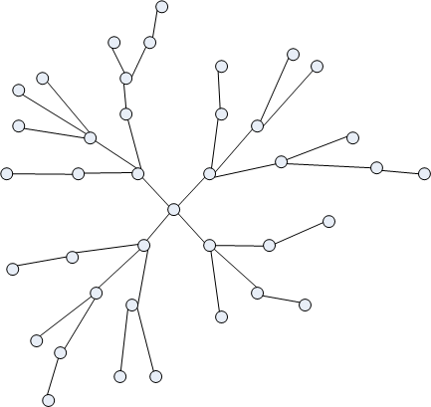
Modbus to DNP3 Protocol Converter
Senior Design I, Fall 12/Spring 13
6 December 2012

Group 24:
Joshua Daly
Daniel Doherty
Mac Lightbourn
Joseph Wilkinson
TABLE OF CONTENTS
1 Introduction
  - Executive Summary…………………………………………………………….………….…………….……..1
  - Motivation…………………………………………………………………………………….……………..……..3
  - Project Requirements………………………………………………………….……….……………………...4
  - Similar Technology………………………………………………………………..……………………………..5
1.4.1 Pro-Soft DNP 3.0 Communication Module………………………….….……………….…...5
1.4.2 DCB EtherGate EGT-1R………………………………………..……………………………………….6
1.4.3 RuggedServer RS910…………………………………………………………………………….……...7
1.4.4 Kalkitech Sync………………………………………………………………………………………………9
1.5 Proposed Solution………………………………………..…………………………………………………….10
1.6 Gantt Chart………….………………………………………..……………………………………………………12
2 Hardware Design
2.1 Hardware Broad Overview………………………………………………………………………………….14
2.1.1 Hardware Block Diagram………………………………………..…………………………….15
2.2 Controllers………………………………………..………………………………………………………………..16
2.2.1 Choosing a Microcontroller…………………………………………………………………..16
2.2.2 Special Features of the MC9S12XDP512…………………………………………..……17
2.2.3 Choosing Between 112- and 144-Pin Options………………………………………..18
2.2.4 External Clock………………………………………..……………………………………………..19
2.2.5 Ethernet Integration………………………………………..…………………………………..19
2.2.5.1 Ethernet Components………………………………………..…………………..19
2.2.5.2 Ethernet Controller Clocks………………………………………………………20
2.2.5.3 Ethernet Interface…………………………………………………………………..21
2.2.5.4 Ethernet Controller Pin Layout……………………………………………….25
2.2.6 Microcontroller Resets………………………………………………………………………….26
2.2.7 Ethernet Controller Resets …………..……………………………………….……….…..27
2.2.8 MCU Pin Layout ………………………………………..………………………………………..27
2.3 Power Systems………………………………………..…………………………………………………………30
2.3.1 Main Power Supply………………………………………..………………………………….…30
2.3.2 Surge Protection Circuit………………………………………..……………………………...31
2.3.2.1 Metal Oxide Varistor……………………….………………..……………………32
2.3.2.2 Transient Voltage Suppressor………………………………………..……….32
2.3.3 DC-to-DC Converter………………………………………..…………………………………….33
2.3.4 Switching Regulator………………………………………..……………………………………34
2.3.5 Microcontroller Power Supply………………………………………..……………………35
2.3.5.1 Microcontroller Internal Voltage Regulator…………………………..36
2.3.6 Microcontroller Power Mode………………………………………..……………………..36
2.3.7 Ethernet Controller Power Mode………………………………………..………………..38
2.3.8 Clock Back-Up Battery……………………………………..……………………………………38
2.4 User Interface………………………………………..……………………………………………………………39
2.4.1 Overview of the User Interface………………………………………..……………………39
2.4.2 Push Buttons and LED Lights………………………………………..……………………….41
2.4.3 Display………………………………………..………………………………………………………..43
2.4.4 Manual Reset Operation………………………………………..…………………………….47
2.4.5 Programming Module Port………………………………………..………………………….48
2.5 Case………………………………………..……………………………………………………………..…………..48
3 Software Design
3.1 Modbus Protocol……………………………………………………………………………………..…………51
3.2 DNP3 Protocol………………………………………..…………………………………………………………..54
3.3 Development Environment………………………………………..……………………………………….56
3.4 Software Life Cycle………………………………………..……………………………………………………57
3.5 Information Flow………………………………………..………………………………………………………61
3.6 Code Design Process………………………………………..…………………………………………………66
3.7 Flow Diagrams………………………………………..………………………………….....………..…………68
3.7.1 Data Change From Modbus Side………………………………………..…………………68
3.7.2 EventTimer………………………………………..…………………………………………………69
3.7.3 Record Event………………………………………..………………………………………………70
3.7.4 Send Error………………………………………..…………………………………………………..71
3.7.5 DNP3 Decode………………………………………..………………………………………………72
3.7.6 Convert to Modbus………………………………………..…………………………………….73
3.7.7 Sync Date/Time………………………………………..………………………………………….74
3.7.8 Check Modbus………………………………………..……………………………………………75
3.7.9 Convert to DNP3………………………………………..…………………………………………75
3.7.10 DNP3 Encode………………………………………..…………………………………………….76
4 Design Summary
4.1 Hardware Design Summary………………………………………..……………………………………….77
4.1.1 Surge Protection………………………………………..…………………………………………77
4.1.2 Reset Sources………………………………………..……………………………………………..77
4.1.3 DC-to-DC Converter………………………………………..…………………………………….78
4.1.4 Case………………………………………..……………………………………………………………78
4.1.5 Power Supply Subsystem………………………………………..……………………………79
4.1.6 Ethernet Interface Subsystem………………………………………..…………………….80
4.1.7 User Interface Subsystem………………………………………..…………………………..81
4.1.8 Hardware Design Diagram………………………………………..………………………….81
4.2 Software Design Summary………………………………………..………………………………………..82
5 Prototype Construction
5.1 Parts and Acquisition……………………………………....…………………………………………...……87
5.2 PCB Vendors and Assembly………………………………………..…………………….………………..90
5.2.1 Circuit Board Assembly………………………………………..……………………………….90
5.2.2 PCB Specifications………………………………………..………………………………………92
5.2.3 PCB Vendor………………………………………..………………………………………………..93
6 Testing
6.1 Hardware Testing………………………………………..……………………………………………………..95
6.2 Software Testing………………………………………..……………………………………………………..108
7 Administrative
7.1 Financials………………………………………..……………………………..…………………………………123
7.2 Milestones………………………………………………………………………………………………………..124

1 Introduction

1.1 Executive Summary

The Modbus to DNP3 protocol converter is a device that Motor Protection Electronics (a designer and manufacturer of industrial controls for the water and wastewater industry) will use in lift stations to facilitate network communications between network nodes that use different protocols. Currently, all of MPE’s pump controllers follow the Modbus protocol. For decades this has been the most commonly available protocol for devices within SCADA networks, though by no means is it the industry standard. MPE wishes to revamp its product line to follow the newer DNP3 protocol, which is more sophisticated and efficient than Modbus although more difficult to implement. The device outlined in the following documentation will act as a gateway anywhere in the network of pump controllers that a device using the Modbus protocol needs to communicate with another device using the DNP3 protocol. Perhaps not as flashy as some other senior design projects, the protocol converter nevertheless will fulfill a real-world need and provide a tremendous challenge to the design team in the field of embedded systems.
The protocol converter will be small (similar to the size of an Ethernet signal divider) and attach to a DIN rail in the control panel of a lift station. The converter will connect with the control panel through a pair of Ethernet ports and convert its native Modbus data stream to DNP3. The output signal will feature reduced data loss, making it more reliable for status-tracking, which is a critical consideration for any utility industry network. The DNP3 signal also requires very little bandwidth to transfer large amounts of data and provides a method of time synchronization of slave devices. A key feature of the DNP3 protocol is time stamping of data, and this data will be logged in the memory of the MCU used in the protocol converter.
Over the next one hundred and twenty odd pages you will be see how the project was split up and designed by our group. First you will be introduced to the motivation behind the device and the requirements of a successful design. This is not the first time this problem has been tackled, so you will be introduced to alternative solutions that are already in existence, followed by the solution proposed by the design team.

The project was broken down into two main houses: the hardware design team and the software design team. In the hardware design documentation, you will learn all the important facts about how the device will be made. This includes how the microcontroller was chosen and why it was so important to use that chip. The power systems of this device were also very important to the overall design so you will be taken through the thought process behind the surge protection and the voltage regulator. The case design will also be included in the hardware section because it was a factor in how the board will be laid out. Lastly in this section, the design for the display is covered: why it is needed and how the design team chose to implement it.

The software design section contains a very short background on both Modbus and DNP3 so you can understand how the information flows better. It also covers the group’s approach to how it selected a development environment in which to work and what kind of lifecycle best fits the project. This is followed by a high level information flow of the overall device, the process that the group went through in designing the code, and finally, the flow of the lower level code design.

In the design summary section you will be given a general overview of how the project was created. This includes both hardware and software design. This will take the entire design process into account and give you an idea of how the group approached and solved various hurdles over the course of the first semester, as well as talk about how the two very different design processes intertwined.

The next two sections cover how the team plans on acquiring parts and assembling the device as well as testing the prototype on both a hardware and software level. The testing is extremely important because the device needs to be very reliable – it will be put to real-world use right away, after all.

The final section of this documentation covers the administrative aspects of the project. This includes everything, starting with a breakdown of expenses, taking into account both the hardware part acquisition as well as the software expenses and the funding itreceived from Motor Protection Electronics. The paper will then go over the major milestones of the project and a timeline of when they are expected. The documentation will conclude with a review of how the workload has been and will be split among the group’s members.

1.2 Motivation
On the first day of senior design project discussions Mr. John Evans from Motor Protection Electronics pitched the idea of designing a gateway device to take two different protocols and making them talk to each other. He went on to describe the nature of what the device is used in. It was to take a protocol that is used in waste water lift stations since the 1970’s and convert it to a newer protocol that has been in use in electrical utilities for over 10 years. The group found this project interesting as one of its members, Josh, had built waste water lift stations previously, and the group had an even mix of electrical and computer engineer majors, which it seemed was called for by this project. After meeting with John Evans and Chris Parker from MPE, the group found the project to be a good fit for what each member hoped to get out of senior design.
The undergrad curricula for EEs and CPEs offer a wide array of courses covering topics from basic electrical circuitry and low level programming to digital signal processing and high level software design. Each of these courses offers something new to learn but it doesn’t teach much beyond the theory of how engineering problems in electrical and computer fields are approached. This project was enticing because it allowed the group to take the theory each member learned and apply it to something relevant and tangible. Design an embedded system from the ground up presents a great challenge for the group, or anyone for that matter. The challenge of learning how to pick a microcontroller that will satisfy all of the project requirements was the first that had to be tackled. Having all taken an embedded systems course the group understood the basics of microcontrollers but had no idea how to take the projects requirements and translate them into choosing a microcontroller that would meet our needs. The next challenge was understanding how different components on a circuit come together to create subsystems and the system as a whole: components like Ethernet controllers, LED displays, USB interfaces, power supplies, voltage regulation, and surge protection.
The software design challenge of making two completely different protocols “speak” to each other provided the final push by our group to accept the project. Learning how to cross compile software is a skill in great demand in the job market and provided our group a leg up on the competitive job market. Even with the software needing to be designed in C language and then compiled into assembly, the learning curve is steep. First having to find a development environment that would optimize the compiling from the upper level language of C to the lower level assembly language proved to be a large hurdle. Once that was passed, the group began the journey to understand how to access specific registers inside the microcontroller from higher level software.
Beyond the desire to learn and put into practice much of what was learned in previous courses, the group picked this project for a few other reasons. Not having to search for a way to fund the project was a bonus as it was fully sponsored by MPE. By building this gateway the teamhelped to push a vital municipal system into the 21st century. It has data security built into it to help counteract anyone that would want to disrupt the systems. It allows for two-way monitoring of the substations. Allowing the station to send a message to the control center if there is power loss or an error at the station and allowing the control center to pull real-time data from the station.
1.3 Project Requirements
External Requirements:
- Case must attach to DIN Rail
- Case must have a display to view settings
- Must allow user to set and select different settings
- Must include power port
- Must include two Ethernet ports
- Must operate between -10ºC and 80ºC
Power Requirements:
- 24 V DC power plug input
- Must have built in surge protection for up to 220V
Battery Requirements:
- Back-up battery attached to system clock
- Must keep system clock intact for 12 hours to allow for all data to be stored and to send an emergency signal to master control center
Circuit Board Requirements:
- 2 Ethernet ports
- Cyclone programming port for programming MCU
- 24 VDC input port
- Triple 7-segment display
- 4-layer PCB board
- Chassis ground connected to power plane of PCB
- Slot to fit 144-pin MCU
Software Requirements:
- Must support both Modbus and DNP3 protocols
- Must have data security of DNP3 level 3
- Must maintain 20,000 event log for errors
- Must maintain current date and time
- Must notify master when a value changes at the lift station
- Must maintain a 98% accuracy of events
- Must have a 95% accuracy of information on first transmission
- Must store all event errors upon power loss and transmit when power is restored
1.4 Similar Technology

1.4.1: Pro-Soft DNP 3.0 Master to Modbus Master/Slave Communication Module

This offering from Pro-Soft comes in a compact metal case and attaches to a DIN rail mount, both of which are specs given for this project. Where this product parts ways with what MPE wants is that it features only serial ports. The device covered in this documentation must handle an Ethernet input and output. Figure 1.4.1.1 shows Pro-Soft’s converter.

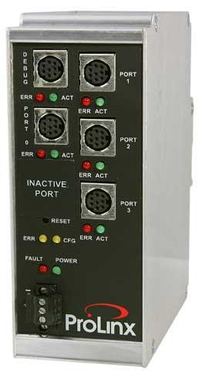
Figure 1.4.1.1: DNP 3.0 Master to Modbus Master/Slave Communication Module
Reprinted with Permission from Pro-Soft Technology
The next figure gives a detailed overview of some of the specs on the signal flow of the Pro-Soft device from both the DNP3 side and the Modbus side. Such information about other protocol converters has proven difficult to come by; this will be a great help to the design team.

DNP 3.0 Master Protocol Specifications | Modbus Protocol Specifications
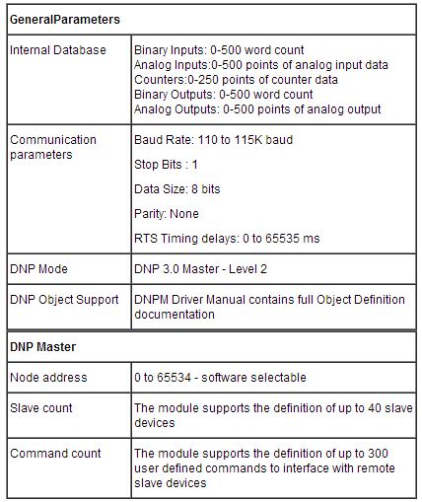 | 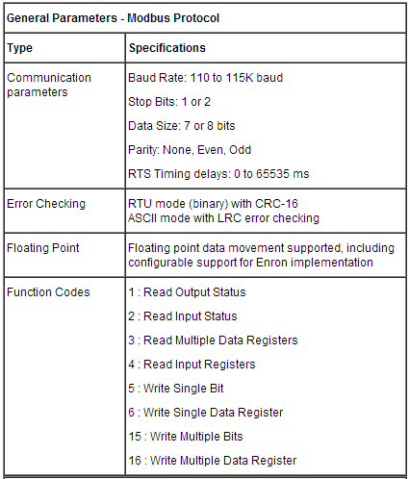

Table 1.4.1.1: Signal flow specs for Pro-Soft gateway
Reprinted with Permission from Pro-Soft Technology

1.4.2: DCB EtherGate EGT-1R Single Port SCADA Ethernet

DCB’s Ethernet modem is tailor-made for use in SCADA networks and is compatible with both the Modbus and DNP3 protocol. It allows the operator to configure network parameters via telnet, serial, or a web browser. While not a gateway in the traditional sense, it does allow communication between devices on either of the protocols by way of a central host. This central hub approach is a viable option open for consideration by the design team. Figure 1.4.2.1 shows the modem.

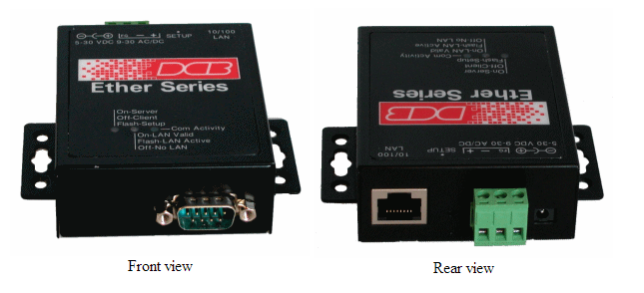
Figure 1.4.2.1: EtherGate EGT-1R Single Port SCADA Ethernet "Modem" DNP-3 and Modbus Protocol-Aware.
Reprinted with permission by Data Comm

1.4.3: RuggedServer™ RS910 2-Port

Ruggedcom’s RS910 is a serial device server featuring 3 Ethernet ports. It can deal with a wide range of protocols and withstand harsh environments. Considerations that are holding it back from fulfilling MPE’s intended application are the bulky size and prohibitive cost of the converter. The RS910 is designed to do much more than Modbus to DNP3 protocol conversion; it is a power saw when all that is needed is a chisel. Figure 1.4.3.1 shows the product.
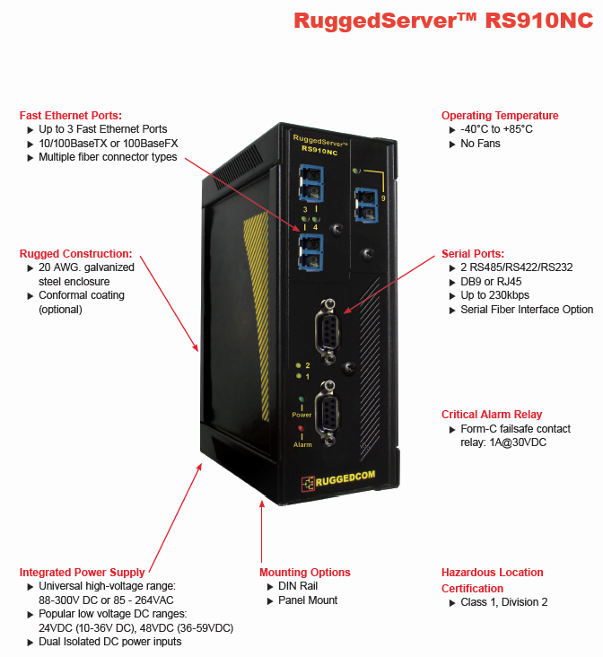
Figure 1.4.3: RuggedServer RS910 2-Port
Permission pending from Ruggedcom

Features of the RS910 are outlined in figure 1.4.3.2.
Figure 1.4.3.2: Benefits and features of the RS910
Permission pending from Ruggedcom
1.4.4: Kalkitech Sync
Similarly to Ruggedcom’s offering, the Kalkitech Sync 3000 serves as an all-encompassing central hub for substation communication devices. It was designed to suit the needs of power substations rather than the less demanding needs of water and wastewater treatment substations. While it would certainly do the job required by MPE, its extra capabilities would go to waste. The product comes in many different cases with different numbers of ports available, as shown below.
Figure 1.4.4.1: Kalkitech Sync 3000
Reprinted with Permission

Figure 1.4.4.2 gives an idea of what a robust protocol converter like the Sync has to offer. This gives the design team something to consider when brainstorming features to add.
Figure 1.4.4.2: Features of the Kalkitech Sync
Reprinted with permission from Kalkitech

1.5 Proposed Solution
With many solutions available to convert DNP3 to Modbus why design another? Cost, for one, as most of the converters are too costly for the needs of MPE. Having devices with more features and capabilities is useful to market to an industry as a whole, but the desired device fills a very specific niche. Therefore any extra features would be wasted and only increase the cost. Also, most of the systems available are for serial connections with possibly one port for Ethernet support. This again won’t work for MPE’s needs. They need to support two Ethernet ports: one for the Modbus connection and one for the DNP3 connection.
After reviewing each of the solutions currently available the team designed a much simpler device that met all of the requirements set forth by MPE. started with a Freescale microcontroller using Motorola’s MC68HC12 assembly platform. The controller comes with multiple memory and pin configurations. The team erred on the side of caution and chose one with 512 KB of flash memory and 32 KB of ram. By taking this approach the team felt that it would cover all necessary storage requirements without the need for external memory. Also once the device is completed and ready for production a smaller controller can be used without the need to redesign the system. then decided to use two Ethernet controller devices to handle each of the protocols separately. This choice made sense to everyone involved by allowing us to use the software to handle each protocol and do the conversion in software instead of hardware. The design also includes a display to allow the end user to set a variety of parameters ranging from the update time cycle to the system date and time. An external clock with backup battery will be implemented for the purpose of maintaining the date and time of the system in the event of power or communication loss. Figure 1.5.1 shows an early concept sketch.

Figure 2.5.1 Concept Sketch
The system will be designed around a 24VDC input per MPE. This design condition sidesteps the need for UL® approval. Inside the circuit there will be surge protection built in to avoid any issues with power surges, a very important design consideration for a device that will be used throughout Florida, the lightning capital of the world. This device will fit the needs of MPE and meet all of its design requirements.

1.6 Gantt Chart
The following chart outlines the project schedule.
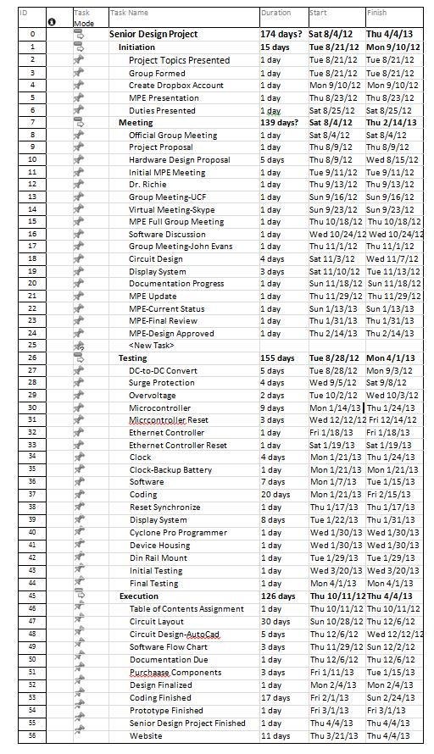
Figure 2.6.1: Gantt Chart
2 Hardware Design
2.1 Hardware Broad Overview
The hardware system design will deal entirely in DC power. In the environment in which the protocol converter will be housed, there is a supply of 24V DC power already available that is being used to power other devices involved in controlling the lift station. With no AC power to deal with, it is a straightforward task to deliver the necessary voltage to the MCU while staying within the UL standards. To avoid damage from high voltage spikes, the incoming 24 V of power is filtered through a surge protection subsystem before passing through a DC to DC converter that will deliver 3.3V to the microprocessor. The converter was chosen over a cheaper and easier to implement passive voltage regulator because the current drawn by the regulator would likely be too great.
To allow for the time-stamping and logging of data, a clock with a back-up battery (CMOS) was incorporated into the design. The MCU will periodically poll the Ethernet controller that deals with the Modbus input, and it must transmit to and receive data from an external clock upon each poll operation. Clocks are also needed on each of the two Ethernet controllers. On the suggestion of our sponsor, the design team chose to couple CMOS clocks with the controllers as well. This allows for a circuit that is less susceptible to electromagnetic interference versus using a crystal oscillator.
The input and output of the converter box will both use the networking technology of Ethernet. For the hardware designers, this necessitated the inclusion of two Ethernet jacks into the circuit. Ethernet jacks come in several varieties, some of which include electromagnetic isolation modules, so the design team made sure to choose one such jack to bypass the need for incorporating an isolation module separately. System input and output are both interfaced with the MCU using Ethernet controller chips, which will govern all network communications.
The guiding principle in the design of the user interface was that of simplicity. As such, the only hardware requirements for it are a handful of push-buttons, a couple of stand-alone LED lights, and a 3-digit 7-segment display. Each LED or segment will be driven by power supplied directly by the MCU.
For easy reprogrammability during the debugging phase, one 6-pin Motorola BDM (Background Debug Mode) port will also interface with the MCU. The design team hopes to procure from the sponsor a Cyclone Pro Programmer unit, which is a flexible tool for programming, debugging, and testing our product. But if this cannot be done, most any programmer module that is compatible with the microcontroller may be connected using this BDM port.

2.1.1 Hardware Block Diagram
The following is not meant to show a complete design with specific part numbers but rather a bird’s eye view of the circuit with qualitative descriptions for all of the key sub-systems and signals. A fuller understanding of these sub-systems will be developed later in the documentation.
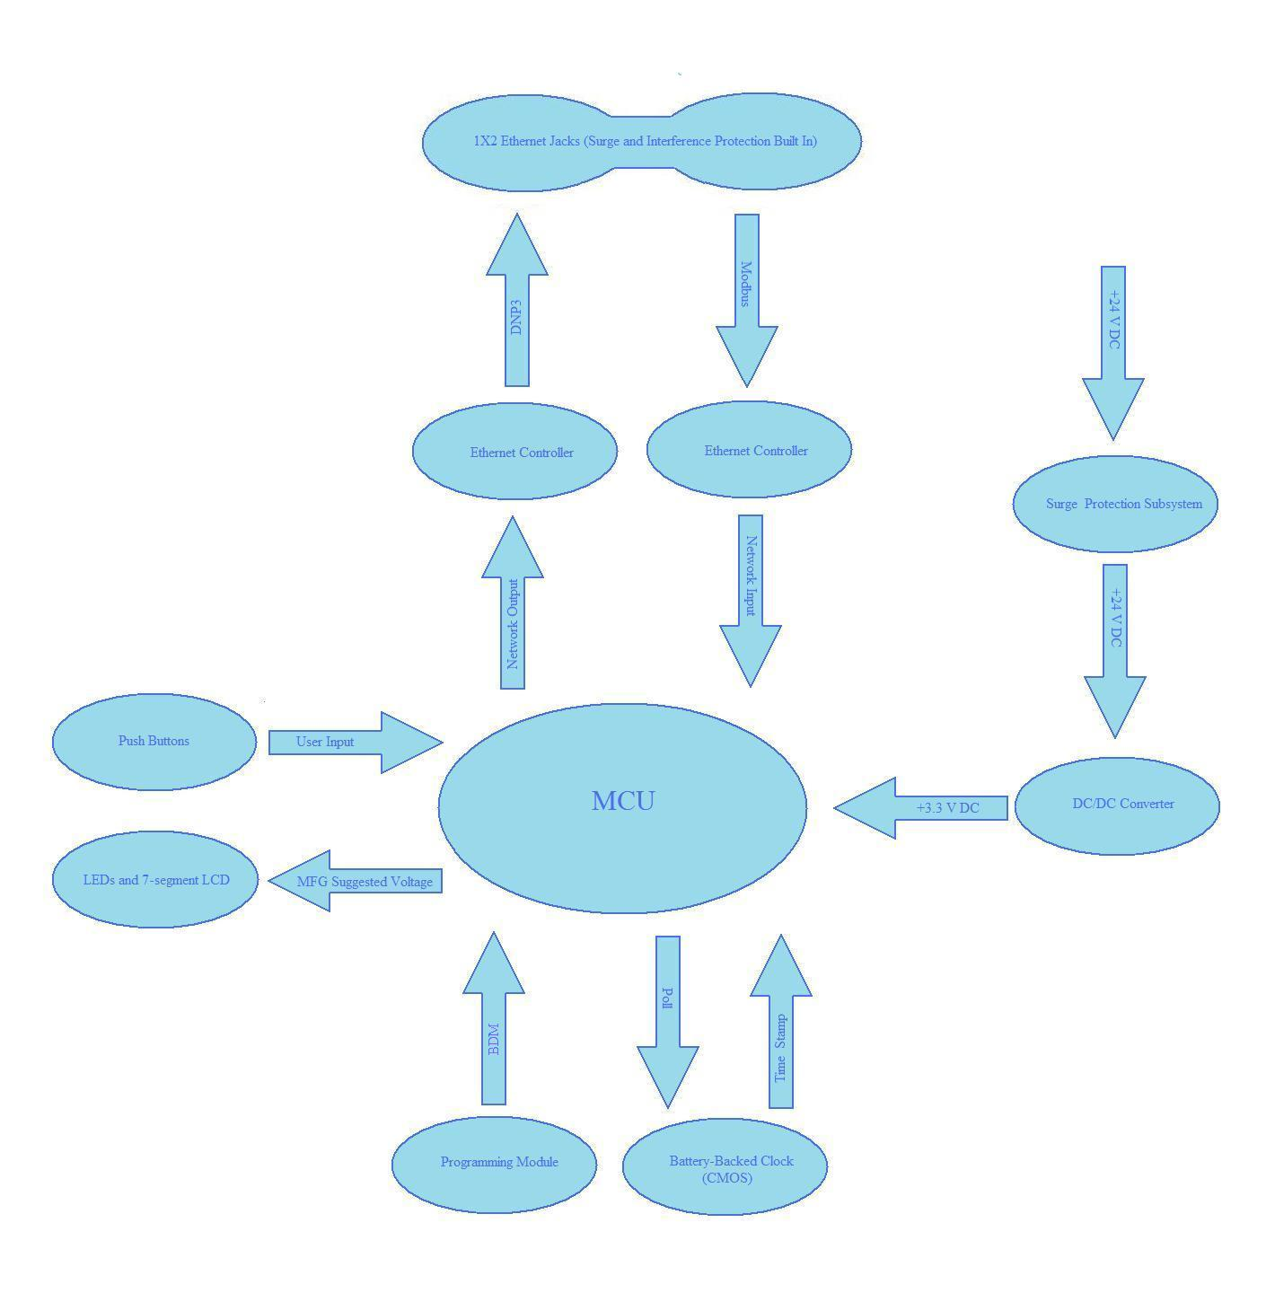
Figure 2.1.1.1: Hardware Block Diagram
2.2 Controllers
As one might guess from the previous diagram, the key component of the project is the microcontroller. Not only will it perform the essential task of Modbus to DNP3 protocol conversion, but it will also drive every hardware component and subsystem involved in the device after the surge protection and voltage regulation subsystems. Therefore, special attention was paid when deciding on a microcontroller around which to center the project.
2.2.1 Choosing a Microcontroller
The specifications given about the project gave serious constraints on the choice of a microcontroller. Perhaps the most important specification handed down by the sponsor about the protocol converter is that it must be able to store 20,000 events in memory, where an event is defined as a register change. This calls for a chip with a large amount of memory, and because the design team needs to be prepared for a lengthy debugging process, that memory should at least in part be flash or EEPROM so that the chip can be reprogrammed many times. Another specification is that the device must deal heavily in Ethernet networking, a technology not typically built into microcontroller chips – it must take in an Ethernet input, perform the protocol conversion, and give an Ethernet output. It should include a memory stack to help streamline the coding process and it must be able to handle a reasonable current for driving all of the other hardware components in the system. For all of these reasons, the choice of a microcontroller was limited to those on the more sophisticated end of the spectrum.
The group’s immediate thought was that one of the few chips with built-in Ethernet support would be the best fit for this project. After a careful examination of offerings from the PIC, Stellaris ARM Cortex M3, and Freescale 68HC12 families, one such chip – the MC9S12NE64 by Freescale Semiconductor – was chosen initially. It is part of Freescale’s 68HC12 family of microcontrollers which is used in other devices produced by the project sponsor. Indeed, their flagship pump controller implements this very chip. Therefore an additional advantage of this choice would be the low learning curve for the sponsor when the finished product is handed over to them. Also, an application note published by the manufacturer gave the schematic for Ethernet implementation by interfacing RJ-45 Ethernet jacks directly to the MCU, effectively completing a large portion of the design.
It was originally thought that the 64 KB of flash memory of the MC9S12NE64 would be more than enough to handle the task called for in the spec, making it the perfect choice as the heart of the protocol converter. The project sponsor, however, had doubts. In order to be absolutely sure that enough memory was available, the design team was forced to choose another chip. It erred on the side of caution and settled on the MC9S12XDP512, another member in the same family as the previous choice of MCU. This provides 512 KB of flash memory – probably overkill, but undoubtedly enough to avoid the disaster of running out of memory when the hardware design is finished and the programming is well underway.
2.2.2 Special Features of the MC9S12XDP512
The MC9S12XDP512 is a robust and powerful chip running on RISC architecture. With it, Freescale introduced the XGATE module, a built-in peripheral co-processor that is available in three of the four modes of operation for this chip. The module is active any time the internal clock (not to be confused with the external CMOS clock) is active. Using a separate RISC core, it pre-processes instructions and data to soften the interrupt load seen by the CPU, increasing instruction and data throughput. This is quite the significant aide for the protocol converter, which will continually process input data and deliver output data to the next device in the pump control system.
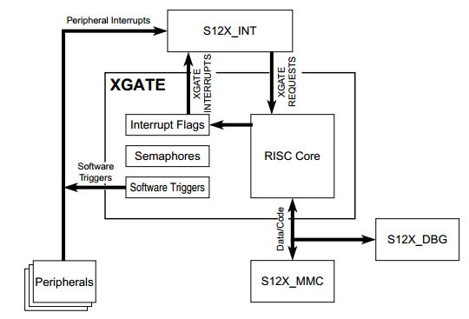
Figure 2.2.2.1: XGATE Block Diagram
Permission Pending From Freescale Semiconductor
The 144-pin version of the MC9S12XDP512 chip includes three serial peripheral interface (SPI) ports, which are useful for controlling peripherals such as Ethernet controllers in a master-and-slave arrangement. Many of its pins are multi-purpose, so a given pin might be used for part of an SPI port as well as a standard address port as well as a pin for another, more specialized signal, depending on the intended application and mode of operation. Another feature exclusive to the 144-pin version of the MCU is a non-multiplexed external bus interface, allowing for easy access to outside components.
All variations of the MC9S12XDP512 include a phase lock loop circuit to regulate power consumption automatically. This is a tremendous benefit for an application such as the protocol converter in which the MCU is delivering power to multiple components. The chip features a low-voltage reset that asserts itself whenever the driving voltage is detected as low and a power-on reset to adjust all output pins to standard operating voltage upon startup. This feature makes it easy to synchronize the resets of all components of the system and keep tabs on the status of all MCU pins when the MCU is powered on.
2.2.3 Choosing between 112- and 144-pin options
The Modbus to DNP3 protocol converter is not intended to be a one-off prototype for demonstration purposes but instead a solution to a real world problem that will go into production with as few changes as possible. For this reason, cost-saving is a key design consideration. The only more important consideration is making sure the components are sufficient to meet the project specs. When making the decision regarding which variety of the MCU will be used in the final design of the converter, both of these considerations came into play.
The MC9S12XDP512 MCU comes in three varieties: 80-pin, 112-pin, and 144-pin. The design calls for roughly 70 pins to be used, but the 80-pin option does not include enough ports with which to work. Therefore the choice came down to either the 112- or the 144-pin option. In keeping with the idea that it is better to err on the side of caution and make sure that enough pins are available for any surprise additions to the circuit later in the design, the team initially chose to work with the 144-pin chip. Later it became evident that a 112-pin chip might be a viable option, and the project sponsor urged that a 112-pin chip be used if at all possible.
After very careful consideration, the hardware design team chose to stick with the 144-pin variant, for the following reasons:
- The external bus interface of the 144-pin chip
- Expanded modes of operation are available only on the 144-pin chip
- The 112-pin chip does not include a designated read/write not pin, adding yet another level of difficulty to the task of driving outside components
2.2.4 External Clock
The key feature of the project is the data-logging system that will provide a time-stamped record of each networking event. This is a capability of DNP3 which Modbus does not have, and it is the major motivation behind changing from the old protocol to the new one. To retain time-based configuration memory the way that the DNP3 protocol calls for, it is imperative that a CMOS clock with a backup battery be chosen and integrated into the design.
The MCU has an internal CMOS clock, but for the higher accuracy called for by the data-logging system, the design team chose to connect an external battery-backed clock to the MCU. Upon resetting the MCU, all internal clocks are driven to the same frequency as the external clock connected to the EXTAL pin, and so a frequency of 25 MHz was chosen to match the internal workings of the MCU. Other considerations were durability, temperature resistance, and low jitter. The design team settled upon the Abracon ASEMPC-25.000MHZ-Z-T as it met all of these requirements: it is shock resistant, able to operate at -40 to 85 degrees Celsius, and is classified as a low-jitter clock. Another feature of this clock is the tri-state (high impedance) function, which may be used, if needed, to create a standby or clock-disable mode.
2.2.5 Ethernet Integration
Because the second choice of microcontroller was in the same family as the original, much of the design work completed under the original chip could still be used with minor, if any, modifications. The one major drawback to the change in MCUs was that the MC9S12XDP512 did not include built-in Ethernet support. This created the need for two Ethernet controllers to be incorporated into the design.
2.2.5.1 Ethernet Components
In the course of researching RJ-45 Ethernet jacks for the previous design, which was centered on the Ethernet-ready MC9S12NE64 microcontroller, the design team learned that some RJ-45 jacks produced by Tyco come with integrated magnetics modules. Such modules provided shielding from electromagnetic interference events, a feature that must be included one way or another in the final product, so incorporating these jacks led to a simpler design and a less expensive product. When it came time to decide on which Ethernet controller to use, the choice was an easy one because only one controller is compatible with the Tyco jacks: the CP2200/2201 produced by Silicon Labs.
The CP2200 and CP2201 are both single-chip Ethernet controllers that provide an additional 8 KB of flash memory which can be used by the MCU. The difference between them is that the CP2200 is not multiplexed, so it interfaces with the MCU through dedicated address and data buses. The CP2201 is multiplexed, and interfaces with the MCU through a dual-purpose address and data bus. In the interest of performance and in taking advantage of the MCU’s external bus interface, plus the multitude of available pins, the CP2200 was chosen for the design. Ports A and B on the MCU are set aside for address buses and so they are connected to the address buses of the Ethernet controllers. Ports C and D on the MCU are set aside for data buses and so they are connected to the data buses of the Ethernet controllers.
2.2.5.2 Ethernet Controller Clocks
A separate 20 MHz clock will be coupled with each of the two Ethernet controllers. The data sheet for the CP2200 provides two clocking options with corresponding configuration suggestions: one option that incorporates a crystal oscillator and one that incorporates a CMOS clock. The next two figures show the two clocking configurations in detail.
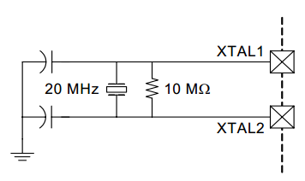
Figure 2.2.5.1.1: Crystal Oscillator Example Schematic
Permission Pending From Silicon Labs
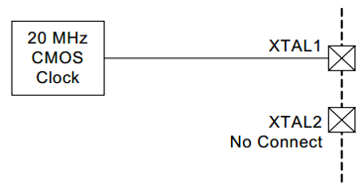
Figure 2.2.5.1.2: CMOS Example Schematic
Permission Pending From Silicon Labs
As is evident from the above schematics, a design that includes a crystal oscillator requires a great deal more components and connections than a CMOS design. Furthermore, crystal oscillators are more susceptible to interference and are sensitive to PCB layout. For these reasons, CMOS clocks will be used in the design.
The specs given for the Ethernet clocks are that they must be 20 MHz and they must operate at a strict minimum voltage of 2 V. For this, the ASEMPC-20.000MHZ-LR-T fits the bill, as it is able to operate anywhere from +3.3 V (which is what the MCU will supply if no voltage divider is used) to +2.25 V. To keep the brand of CMOS clocks consistent throughout the design, this offering from Abracon will be used.
2.2.5.3 Ethernet Interface
The layout for the Ethernet subsystem schematic will be based on the typical connection diagram given in the datasheet of the Ethernet controller (below), which shows how to incorporate an Ethernet jack with integrated magnetics.
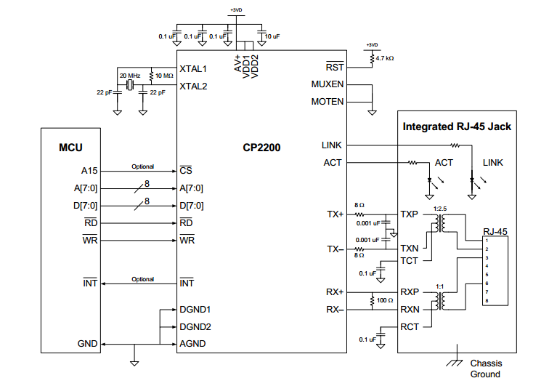
Figure 2.2.5.3.1: Typical connection diagram
Permission Pending From Silicon Labs
The design team followed this schematic layout but extended the design to include two Ethernet controllers. Many other changes were also made based on the design considerations of the project.
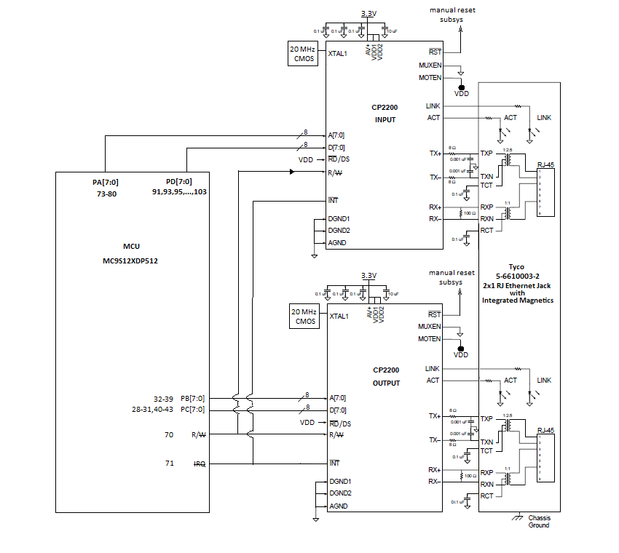
Figure 2.2.5.3.2: Ethernet Subsystem Schematic
Permission pending from Silicon Labs for re-used portions
To save space and reduce production cost, the Tyco 5-6610003-2, a twin-port monolithic Ethernet jack, will be used rather than two separate Ethernet jacks with one port each. The metal casing of the converter will serve as the chassis ground shown in the schematic, which will be tied to the common ground plane used by other components. This is because the voltage of the case and the power plane must be the same so that no charge is built up between them. Such a charge could lead to considerable damage in the case of an electromagnetic interference event, such as a lightning strike.
The LINK connection between the Ethernet controllers and the Ethernet ports drives an LED that indicates whether valid link pulses are detected. The ACT (activity) LED is a push-pull output that is driven high when any packet of information is transmitted and received. It remains in this state for 50 microseconds before returning to its low state.
The reset-not pin can be driven directly by the MCU power supply with no voltage divider necessary. Driving this pin low for 15 microseconds initiates a full system reset of the Ethernet controller. As will be discussed later in the design project documentation, great care will be used to ensure that component resets are synchronized throughout the hardware design.
The Ethernet controllers use separate power supply pins for analog circuitry and for digital logic. The supply for driving the digital logic operations is further split into two pins: VDD1 and VDD2. All three of the total power supply pins take in 3.3 V, so they can all be tied directly together and driven by the MCU power supply without the need for a voltage divider. Capacitors are used in parallel with these power supply pins to negate the effects of sharp changes in the transient response of the power signal. Also, each supply pin has a corresponding ground pin. These too will be tied together, then connected to a common ground.
MUXEN (multiplex enable) determines whether multiplexed bus mode or non-multiplexed bus mode is enabled. The design of the protocol converter is not multiplexed and so this pin will be grounded. Similarly, MOTEN (Motorola enable) determines whether the Motorola or the Intel convention for endianness will be followed. The design of the converter is based on Motorola architecture and so this pin will be connected to VDD (no distinction need be made between VDD1 and VDD2 since they are tied together).
Note that the RD-not pin on the Ethernet controller does not indicate the “read-not” pin as one might presume. Rather, this pin determines whether the read strobe (an Intel convention) or the data strobe (a Motorola convention) will be put into effect. More specifically, the state of this pin controls the function of pin 40 on the Ethernet controller. Since the design is based on Motorola architecture, this pin is driven high by VDD. This gives pin 40 the function of read-write-not. The read-write-not pins on each of the Ethernet controllers are tied to that of the MCU and an inverter is used going into the input Ethernet controller. This ensures that when one of the controllers is in read mode, the other is in write mode, and vice versa.
In the typical connection diagram, it was left as an option to the designer whether to use the interrupt pin of the Ethernet controller. To give the software development team everything that they might need, the hardware design team included an interrupt system in case any event in the networking subsystem requires the immediate attention of the MCU. In this case, a hardware interrupt can be sent by either controller. Both interrupt pins are tied directly to the IRQ (interrupt request) pin of the MCU so that it does not matter which controller sends the interrupt request.
2.2.5.4: Ethernet Controller Pin Layout
The CP2200 Ethernet Controller comes as a 48-pin package in which the pins are not always sequential with regard to their respective groups. For this reason, care will be necessary when connecting the physical chips. The following figure shows the layout of the chip as well as how the different subsystems will interface with it.
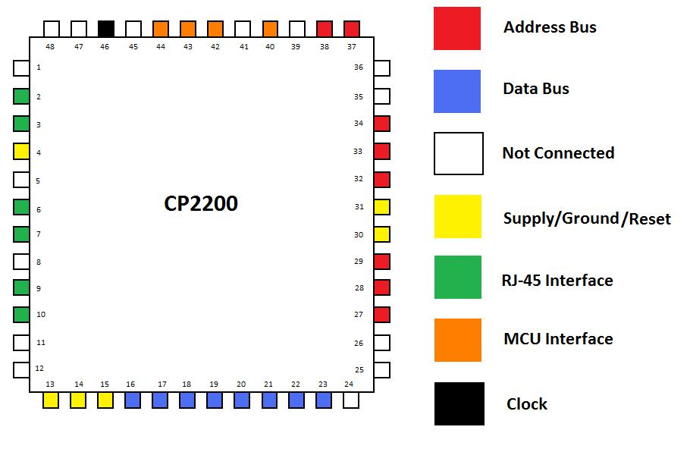
Figure 2.2.5.4.1: CP2200 Pin Diagram
The following table, in conjunction with the diagram above, will provide a quick reference for the design team when dealing with the physical components during the prototyping phase of the project.
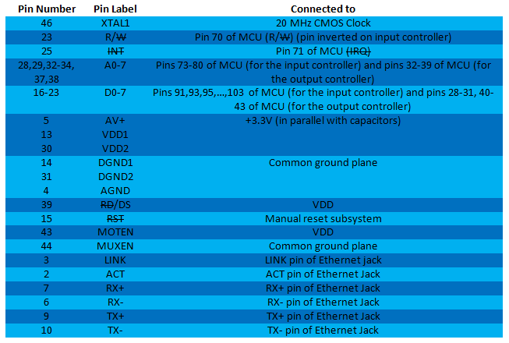
Figure 2.2.5.4.2: CP2200 Pin Layout Table
2.2.6 Microcontroller Resets
Initially, it was made clear to the design team that the microcontroller should take advantage of its built-in reset operation. The Clock and Reset Generators (CRG) controls the reset states of the microcontroller. The MCU registers will not be affected if the microcontroller has to be placed in the reset state. It is mandatory to protect the registers because they play a key role in completing in this project. The microcontroller reset sources consist of the Power-on-Reset, Low Voltage Reset, External Reset, Illegal Address Reset, Clock Monitor Reset, and COP Watchdog Reset. It is safe to say that all of the reset sources add value to protecting the microcontroller and not one source can perform better than the others. As any reset event is enabled, an internal circuit drives the reset pin of the microcontroller low for 128 SYSCLK cycles. The Power-on and Low Voltage Reset protects the microcontroller from unusual power behaviors such as low voltage or the input power supply surpasses the microcontroller’s threshold voltage. In each mode, the CRG will check the internal clock signals. After the check process is completed, the reset sequence starts using the oscillator clock until the clock quality check indicates non-irregular activities. The Computer Operating Properly Watchdog Reset is a self-explanatory reset source that can put the microcontroller in the reset state whenever the computer is not operating properly. A clock reset is needed to guard the clock from nonstandard conditions such as loss of clock, self-clock mode is disabled and clock monitor is enabled. Also, keeping time is an important aspect of our project.
2.2.7 Ethernet Controller Resets
Upon the start of the circuit design, it was pointed out to the design team that reset is a critical feature that is needed for every major component on the circuit board. As said before, protecting the circuit is vital. This project will be used for real-world applications; therefore, using all protection sources will help for future interference. The CP2200 has particular reset sources that automatically put the Ethernet controller in the reset state whenever abnormal conditions occur such as irregular power or the oscillator fails. The reset state will not affect the Ethernet controller’s operation. Registers hold most of the data that is needed for the conversion portion for this project. All of the registers reset values will be placed by their initial values as soon as the Ethernet controller changes to its normal state. The Power-On Mode becomes active during power-up. Respectively, the Ethernet control controller has its own internal power surge protection, which can protect itself. Another remarkable reset source is the power-fail mode. Irregular power will be expected to occur for the circuit thus the power-fail mode will be triggered whenever this event occurs. It sends the Ethernet controller to the reset state until the power supply returns to normal. In the event of the oscillator failing, the oscillator-fail reset will force the Ethernet controller in the reset state for approximately 1 ms. Before the Ethernet controller transforms to its normal state for each reset state, the external oscillator will start to allow the controller to clear up.
2.2.8 MCU Pin Layout
With a 144-pin beast of a microcontroller at its core, the protocol converter system will not be easy to prototype. The design team will forgo using a breadboard for building a prototype due to the complexity of the system. The team instead plans to order an evaluation board to aid in some of the basic hardware and software tests and then create a full PCB design upon completion of the testing. So-called surgery can then be performed on the PCB if any minor changes need to be made.
Because of the leap-before-you-look nature of the prototype phase, knowing the pin layout of the MCU will be of the utmost importance. The following diagrams will help in achieving that end. Figure 2.8.1 shows the layout of the chip and how some key subsystems will interface with it.
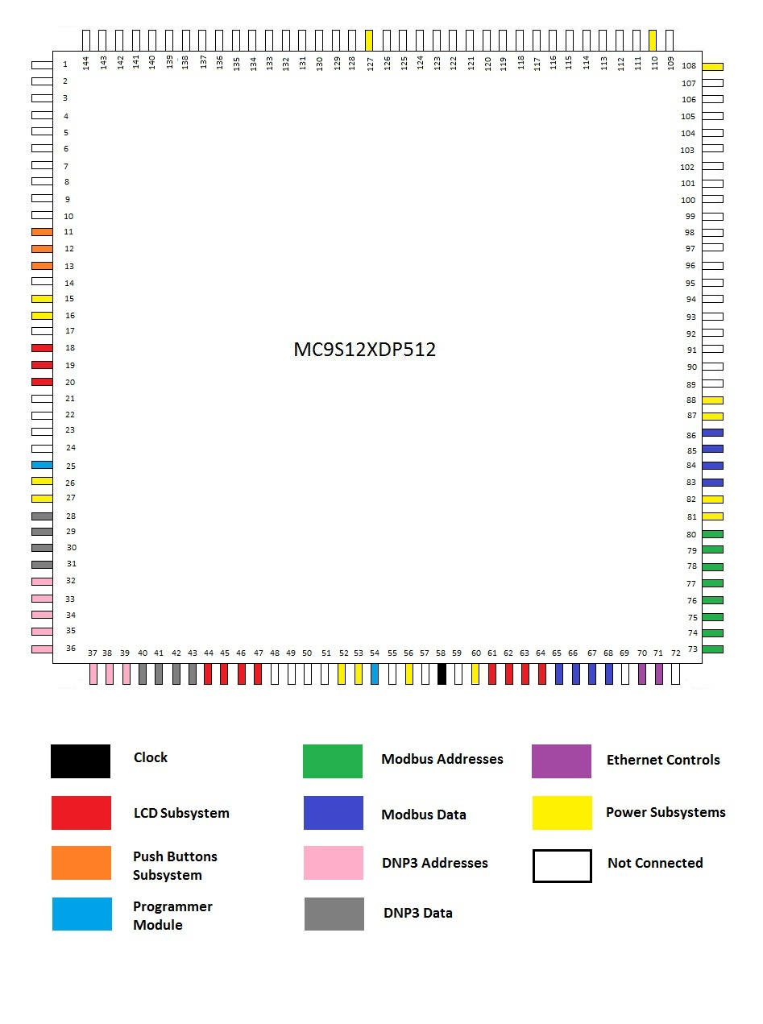
Figure 2.2.8.1: MCU Pin Diagram
66 of the 144 pins on the MCU will be used and the rest grounded. Figure 2.8.1 gives a thorough run-down of each pin’s purpose.
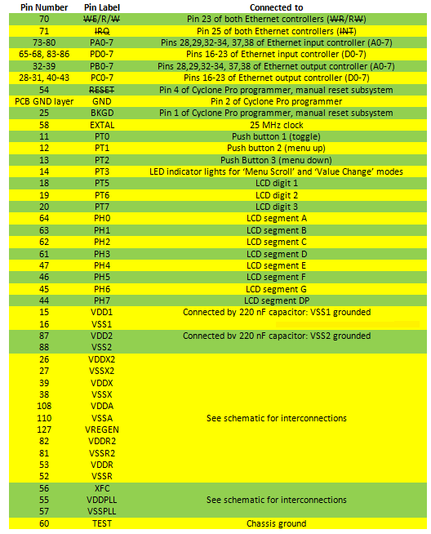
Figure 2.2.8.2: MC9S12XDP512 Pin Layout Table

2.3 Power Systems

Luckily for the design team, no AC to DC power conversion needs to be done and no UL standards need to be considered. The system will be supplied with 24 V of DC power which is used by all devices in the lift station. Unluckily for the design team, the risk of electromagnetic interference and voltage spikes is heightened in the industrial setting in which the protocol converter will be housed. The team must take every measure to guard against these. This section explains how those needs will be addressed and how power will be meted out to all of the system components.
2.3.1 Main Power Supply
A 24V DC power supply is used to supply the circuit board. The power supply will have its own layer on the printed circuit board. This voltage is purposely kept to 24 V, which is considered low, because a higher power supply will need additional testing to satisfy industry standards. As a result, this saved the design team money and time. Keep in mind this product will be distributed. This input supply was then sent through a surge protector to protect the circuit board from any unwanted voltage. Figure 1, below, illustrates how the input power supply is protected, stepped down, and delivered to various subsystems.

Figure 2.3.1: Power Distribution Flow Chart

2.3.2 Surge Protection Circuit
The surge protection circuit is vital to the circuit design. It removes unwanted voltages that are not in our specified range by shorting to ground. This circuit supplies the DC-to-DC Converter with a 24 V DC power supply. The input voltage is then stepped down to produce an output voltage that primarily supplies the microcontroller. The microcontroller acts as the heart for this project. Therefore it is mandatory to have the input supply protected and trustworthy because this component controls each and every network operation.

The surge protection circuit shown in Figure 2 consists of the Metal Oxide Varistor (MOV), Transient Voltage Suppression diode, resistors and a capacitor. The Metal Oxide Varistor and Transient Voltage Suppression diode were not placed as blocking devices in the surge protection circuit for the reason being that as unwanted current is detected, the resistance will increase but the current will only be partially limited; the excess current going through the load can affect the microcontroller performance. To eliminate this problem, the Metal Oxide Varistor and Transient Voltage Suppression diode were connected across the power source in a shunt configuration. As over-voltages are detected, the excess unwanted voltage will go through the surge protection components and not to the DC-to-DC Converter.

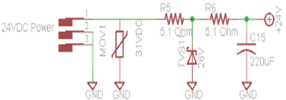
Figure 2.3.2: Power Surge Protection Circuit

2.3.2.1 Metal Oxide Varistor

As said previously, the Metal Oxide Varistor is connected in a shunt design across the power source. It acts as a voltage dependent resistor until its voltage exceeds the threshold voltage. Current (I) acts as a function of voltage (V). As the voltage across the MOV surpasses the threshold voltage (V_{th}), the MOV starts to conduct current significantly to absorb most of the energy. The significant increase in current results in a small change in voltage. Surge protection components were needed for the circuit design that has a long life-expectancy. The Metal Oxide Varistor is considered to have the longest life-span compared to other surge protection components. Once the circuit is operating in different fields, changing components for performance failure has to be avoided by building a durable and functional circuit. The Metal Oxide Varistor used in the design was chosen after careful consideration by evaluating the manufacturer’s energy rating; the energy rating has a huge influence on the MOV life-expectancy. Another reason for choosing the Metal Oxide Varistor is that has the second fastest response time to irregular voltages.

2.3.2.2 Transient Voltage Suppressor

Another important component from the surge protection circuit is the Transient Voltage Suppressor Varistor. The Metal Oxide Varistor should be sufficient for the surge protection circuit but a component was needed to react rapidly to over-voltages that will damage the microcontroller. The Transient Voltage Suppressor is the best surge protection component suitable to fulfill this task. It responds to excess voltages faster than any other surge protection component in its class. The table below shows how fast the Transient Voltage Suppressor Varistor is compared to other surge protection component. This component is capable of absorbing high energy compared to the crowbar device. The Transient Voltage Suppressor Varistor is normally used for high speed and low power circuits. The circuit power supply is considered to be high power according to industry standards so the MOV satisfy this requirement.

Type of transient suppressors | Lifetime-number of surges | Response Time
TVS | - | 1 ps
Metal Oxide Varistor | 1000 surges | 1 ns
Zener Diode | infinite | 1 us
Gas discharge tube | 20 surges | 5 us
Table 2.3.2.2.1: Transient Suppressions Evaluation

2.3.3 DC-to-DC Converter

After our input power exits the surge protector circuit, that supply is then sent to a DC-to-DC Converter circuit that steps down the power supply for use by components on the circuit board. The voltage supply needed for most of the components is 3.3V. The DC-to-DC Converter allows the output voltage to be adjusted by changing the resistor values.
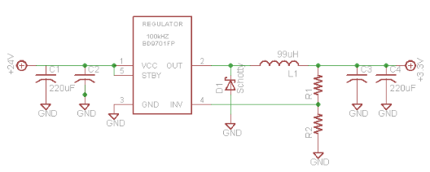
Figure 2.3.3.1: DC-to- DC Converter Circuit

2.3.4 Switching Regulator

The goal for the power circuit design is to conserve as much power as possible and lower the output noise. One of the challenges for the circuit design is choosing the most sufficient and proficient regulator. The linear regulator is known for its low output noise which is a great attribute that is needed for the circuit design; the microcontroller chosen is sensitive to noise. Furthermore, linear regulators are not expensive and fewer parts are required, but they have their disadvantages. They are considered to have poor efficiency. The circuit will see heavy load currents at the input. Linear regulators cannot withstand high load currents; the transistor in the linear regulator wastes the needed energy and distributes it as heat.

In contrast, switching regulators generate more noise and disregard the input noise that is coming into it. Nonetheless, their main features are power conservation and high efficiency. The transistor in the switching regulator is switched on and off to save as much power as possible. The environment where the circuit board will be placed is well-suited to the switching regulator. Sometimes switching regulators do not start in cold environments so the location for the circuit will actually improve the regulator’s performance.

Ultimately the switching regulator was chosen for the circuit design. It satisfies most of our requirements but produces high noise. To eliminate the high noise and maximize efficiency, two capacitors were connected to the input of the regulator and an additional two capacitors were connected at the output of the switching regulator. A Schottky diode was also added to the output of the switching regulator to reduce noise. The switching regulator also acts as a surge protector component, which is an important feature for the circuit design. The regulator has a built -in over current protection circuit that detects when the voltage reaches the threshold value. Also, the manufacturer for the switching regulator recommends their customers use the circuit example they have in their manual. The circuit example given was implemented in the circuit shown in Figure 2.3.3.1. Each component on the circuit board does not operate at 5V; the given circuit has adjustable resistors connected between INV and Ground to regulate the voltage to the desired value.

2.3.5 Microcontroller Power Supply
Several pins on the microcontroller called for 3.3 V of power. The interconnections of the MCU power pins will be based on the suggested PCB layout from the MCU datasheet, given in the following figure:
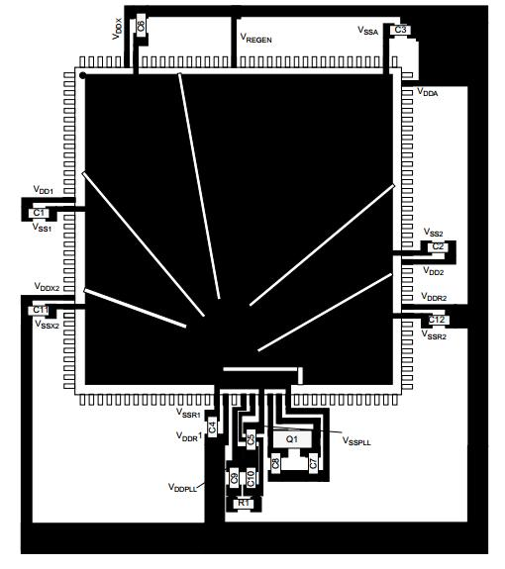
Figure 2.3.5.1: Suggested PCB layout for MC9S12XDP512
Permission pending from Freescale Semiconductor

The microcontroller is equipped with an internal voltage regulator which itself needs power supplied to it. The manufacturer gave a specified range for the input voltage for pins that needed external power. The voltage value being supplied to the microcontroller is 3.3V. The main source of power for the microcontroller is supplied through the VDD and Vss. The manufacturer recommends a bypass capacitor to be placed at every power pin .This requirement is crucial for VDD and VSS pins. Fast signal transitions and short-duration current demands on power supply occur at those pins. Capacitors are also useful to help with any unwanted noise that might have journeyed from the switching regulator. The microcontroller is equipped with an analog –to- digital converter which requires power supply to the reference voltage inputs pins. Highly crucial for the microcontroller, a passive external loop filter was placed on the XFC pin. The purpose for this second-order low pass filter is to remove the VCO input ripple. The stability of the Phase locked loop and the speed of accuracy is determined by the value of the low-pass filter. The V_{DDPLL} provides the supply voltage to the second-order filter circuit. The microcontroller Background and Reset pin will also need power supply. These pins are needed for the USB multilink programmer. This device will be used occasionally to update the microcontroller and debug code. The multilink programmer has many options for its power supply. An additional port will be created to supply power to the multilink programmer if the need arises.

2.3.5.1 Microcontroller Internal Voltage Regulator
The microcontroller has its own internal voltage regulator (VREG_3V3) that outputs two separate 2.5V supplies. It has remarkable features that hinder add-ons to the circuit design to protect the microcontroller. The Low-Voltage Detect (LVD) examines the input voltage (V_{DDA}-V_{SSA}) to sense low-voltage which will then alert the status flag LVDS. VREG_3V3 has another feature that manages over-voltage; the Power-On-Reset (POR) compels the microcontroller into Reset if V_{DD} exceeds or is below V_{PORD}. The Low-Voltage Reset (LVR) function is similar to the Power-On-Reset. It examines the output voltage V_{DD.}

2.3.6 Microcontroller Power Mode
VREG_3V3 can operate in modes such as Full Performance Mode (FPM), Reduced Power Mode (RPM), and Shutdown mode. The Full Performance Modes has all of the qualities that are needed for the microcontroller peak performance. All the attributes for VREG_3V3 are accessible in this mode. Full Performance Mode allows the regulator to be active to supply 2.5V to both outputs. The Reduced power mode is known for reducing power consumption. Compared to the full performance mode, the output voltage value is lower which result in the current source being lowered. Also it does not allow the LVD and LVR to function. The Shutdown mode operates with minimum power use. It has the ability to shut down the internal regulator. However, this mode has disadvantages that were not helpful with achieving the VREG_3V3 highest performance. The regulator outputs are in a high impedance mode, and LVD and LVR are not available in this mode.

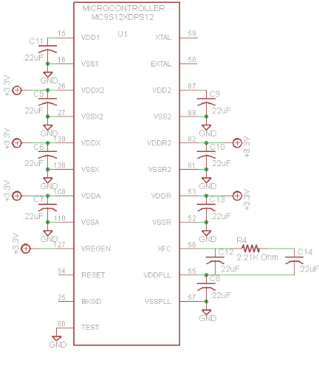
Figure 2.3.4: Microcontroller’s Pins Power Supply

2.3.7 Ethernet Controller Power Mode
Two CP2200 Ethernet controllers were part of the circuit design that needed 3.3V power supply. The controller has four selective power modes that can be utilized to reduce the system power usage. The controller power modes are Normal, Link Detection, Memory, and Shutdown Mode. The normal mode was most convenient for the protocol converter project design. This mode allowed the Ethernet controller to be fully functionally. The other modes have features that will be beneficial to the circuit design certain requirements were not met for each one. The Link Detection Mode was not chosen simply because the transmitter and link pulse generation logic will not be available in this mode. In addition, this mode requires the microcontroller to be in low power mode for a short period of time. Being that the microcontroller is the brain for the circuit board, depriving it from much needed power is an unwanted hazard. Memory Mode has a unique attribute that allows the Ethernet controller physical layer to be in a low-power state. However, the only available functions are the Flash memory and RAM buffers. The mode that conserves the most power is the Shutdown Mode. It is crucial for the Ethernet controller to have all primary and secondary functions available at all times; the shutdown mode disable all of those functions. The system clock is not functional in this mode, which is mandatory for the circuit design.
2.3.8 Clock Back-up Battery

The clock, with its low-power consumption, is essential for the circuit design. The clock chosen, which has a battery switch over circuit, is an NXP CMOS real time clock. Its battery supply voltage range is 1.8-4.2V. The date and time must be available and accurate at all times. To avoid any data being lost if an incident occurs (such as a power outage, power surge, or other interference) a back-up battery was added to last for a specified time. The clock will be depending on the input 3.3V power supply.

The back-up battery only guarantees the clock will have a constant source of power. A 4.2V lithium battery will be used as the clock backup battery. The amount of power being supplied by the back-up battery is sufficient; as stated before, the main power supply only supplies 3.3V. The voltage that is not used by the clock will not be wasted. The clock has a pin that sources the external circuitry with the left over voltage. For instance, some pins from the microcontroller can use that supply to function if a power outage occurs. As previously mentioned, reset sources are needed for every device on the circuit board; fortunately, this clock meets this requirement by having reset sources as a feature.
The battery-back also has various power modes to ensure that power will be conserved, which means battery life will be extended to keep the clock operating for a longer period of time. The standard mode is useful for the clock power system; it acts as a surge protector for the clock power system. If the power supply voltage drops below the battery voltage, the clock supply will be switched over to the back-battery. The smart mode is also an asset to the clock power system. This mode permits the RTC to continue running while conserving the much needed battery backup time. Furthermore, RTC continues to function despite V_{DD} being as low as 2.5V. Unfortunately, this mode only always clock power supply to switch over to the battery unless V_{DD} plunges to 2.2V. This action is not acceptable because the clock cannot operate to its full potential with a 2.2V supply.

2.4: User Interface
Although the essential task of the protocol converter is done automatically, without the need for user input, there arise certain circumstances under which the user will need to interact with the system. For example, the Modbus and DNP3 protocols deal with many different parameters, and the user may want to change one or more of these parameters depending on the application of the product. These include the frequency with which the MCU polls the Modbus Ethernet controller and the format of the data time stamp. As the programming of the protocol converter gets underway, the need for several more setup parameters will likely become evident. Therefore, a versatile hardware design is necessary for ensuring that any parameter deemed important later in the design cycle can be incorporated by the software design team and controlled by the user.
2.4.1: Overview of the User Interface
In designing the user interface, simplicity and ease of use were the major considerations. The design team looked at what the user needs to be able to do and then sought the simplest way to allow the user to do it.
The first thing that the user should be able to do is choose a parameter with which to work, and the next should be to change the value of that parameter. One other way the user might want to control the system is to initiate a manual reset in the case of a system malfunction. To allow for all of these user inputs, only a handful of components were chosen: a 3-digit 7-segment display, four push buttons, and two LED lights.
The LED lights are used to indicate either ‘Menu Scroll’ mode or ‘Value Change’ mode and one of the push buttons is used to toggle between these two modes. Two more push buttons are labeled ‘UP’ and ‘DOWN’ – these allow the user to navigate the list of parameters in ‘Menu Scroll’ mode and raise or lower the value of a parameter in ‘Value Change’ mode. All of this is reflected on the 3-digit display. In ‘Menu Scroll’ mode, short parameter codes will be displayed which will be made available to the user in a separate reference guide. The values of those parameters will be shown to the highest degree of accuracy that three digits allows. To guard against accidental value changes, a time delay will be coded into the MCU such that when ‘Value Change’ mode is selected, the user must depress the ‘UP’ or ‘DOWN’ button for four seconds before any change can be made. The time window in which changes can be made will close when no parameter value change has taken place for four seconds.
The fourth push button is used to initiate a system reset. To avoid unintended user resets, the manual reset button will be sunken below a small aperture such that it can only be depressed with a long, thin object such as a toothpick. With this obstacle between the user and the manual reset button, the button will only be depressed when doing so is intentional.
When the board is being programmed, it will be useful for the design team to take advantage of a built-in BDM port to interface between the programming module and the microcontroller so that wonky, makeshift connections involving the background and reset pins can be avoided and the programming module can be attached and detached quickly. Since this port will be attached to the background and reset pins by the design team, it might as well become a part of the device that can be used by the operator. This way, in the rare case that the user wants to reprogram the microcontroller, he or she may do so.
Figure 2.4.1.1, on the next page, gives an idea of how the device will be controlled by the user. It is not intended to be a complete or even a dimensionally accurate representation of the converter casing as it will look when completed but to show those elements that go into the user interface roughly as the operator will see them.

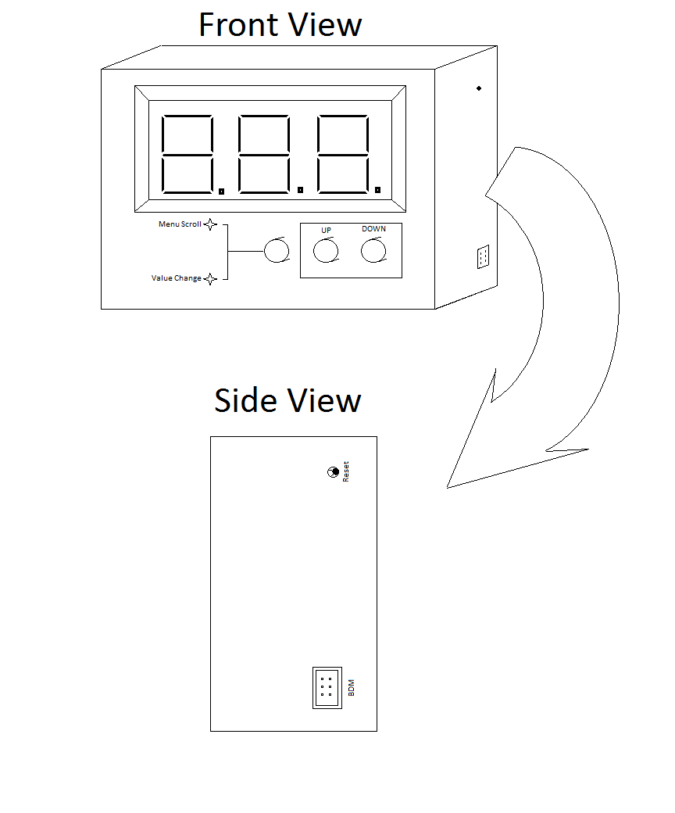
Figure 2.4.1.1: User Interface

2.4.2: Push Buttons and LED lights
The lighting inside of a lift station varies from very dark to very bright, and so LED lights that can be seen clearly in either of these two extremes are necessary for the convenience of the user. For this reason, the two LED lights as well as the segments of the 3-digit display will all be of the super-red variety. For the push buttons, important considerations are that they be non-latching and compact. They should be as small and as closely spaced as can be comfortably pressed by the large-thumbed user.
Luckily, the project sponsor has a large supply of both super-red LED lights and push buttons because both of these components are common throughout their product line. Any such components needed for the prototyping of the protocol converter will be sampled from them.
In wiring the toggle, ‘UP’, and ‘DOWN’ push buttons, the project sponsor requested that a button in the closed position would result in a high voltage reading on the MCU pin. Pull-down resistors are used to ensure that a near-zero voltage is present on the pins when the push buttons are not depressed. The two stand-alone LED lights will be wired together and driven by a single pin, with an inverter going into one of them. This ensures that one and only one of the lights will be active at any given time. Figure 2.4.2.1 gives the schematic diagram showing all of these components (the manual reset button will be covered in a separate section)
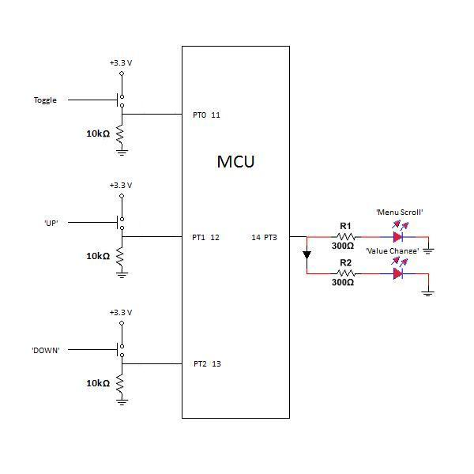
Figure 2.4.2.1: Push buttons and LED lights
2.4.3: Display
The LCD display featured on the protocol converter will be the LTC-4724JR by Lite-On Electronics. This super-red 3-digit 7-segment display has a digit height of 1 cm, allowing for compact casing dimensions while remaining readable. Its multiplexed design allows for 27 separate LED segments to be controlled by 12 pins if no multiplexing is done between the microcontroller and the display module. The device uses its LEDs as switches for determining which digit and which segments within that digit are active. The active digit is determined by which of four common cathodes are pulled low. The active segments are determined by which of eight anodes are driven high. The MCU cycles through the digits at such a frequency that the eye cannot tell that only one of them is active at any given time.
In addition to the seven segments that are used to represent numbers and characters, each digit has a decimal segment. The decimals after the first or the second digit may be used in showing parameter values to greater accuracy than whole numbers. Also, one of the common cathodes controls a colon character used to show time as well as a superscript dot before the last digit. These features will not be used for the protocol converter and so this cathode will remain at a high voltage level when the converter is powered on.
The connections of the LCD display module are summarized in the diagrams below:

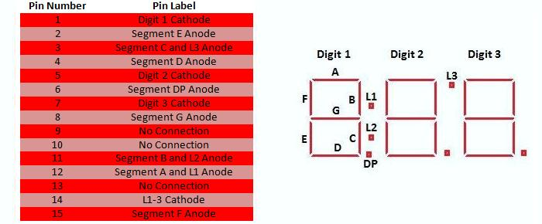

Figure 2.4.3.1: LCD display pins and reference diagram
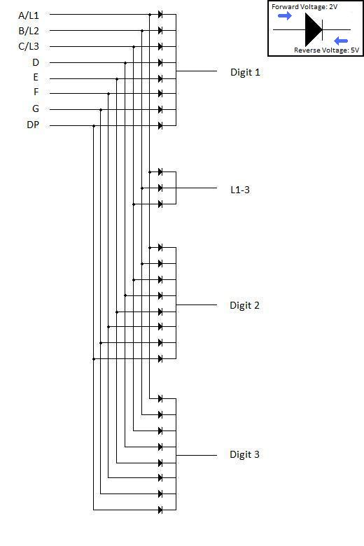
Figure 2.4.3.2: LCD Display Schematic
The forward voltage of the diodes is typically 2 V with a maximum voltage rating of 2.6 V. The initial hardware design used a CP2400 LCD driver by Silicon Labs because this component was preconfigured to drive the anodes within this voltage range. This design requires another clock but sidesteps the need for pull-up resistors on the cathodes and voltage dividers to step down the voltage on the anodes from 3.3 to 2 V. Figure 2.4.3.2 shows the original design that implements an LCD driver.
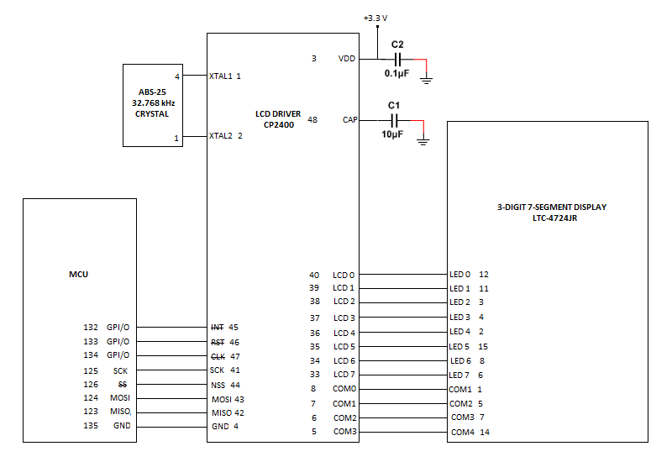
Figure 2.4.3.3: Display Subsystem Schematic Rev. A

At the urging of the project sponsors, the LCD driver was removed from the design to save cost. One common way of driving the LCD directly with the MCU is to use a multiplexed design. This could be done using as few as four I/O pins, but would require three addressable latches and three peripheral driver arrays, plus additional basic components that go along with those. Thinking this to be more trouble than it will be worth, the design team once again took advantage of the numerous available MCU pins and implemented a non-multiplexed design using eleven general purpose I/O pins. Figure 2.4.3.3 shows the second revision of the schematic.
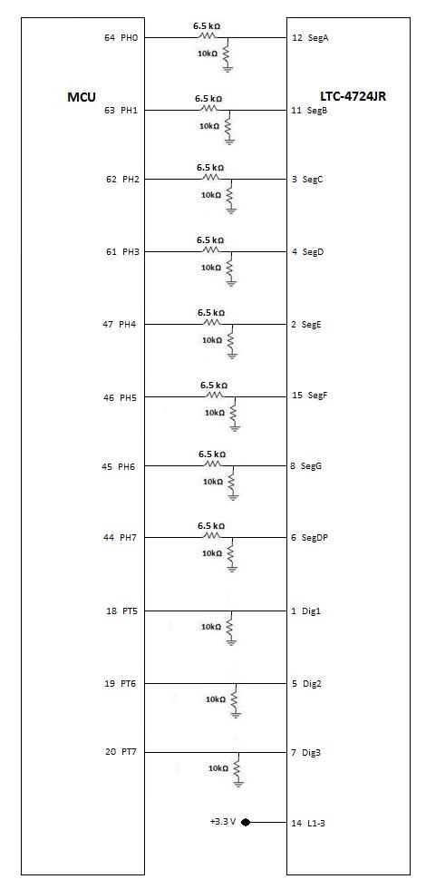
Figure 2.4.3.4: Display Subsystem Schematic Rev. B
2.4.4: Manual Reset Operation
In the course of designing an embedded system, it is vital to consider the condition of each component upon startup and reset. Thankfully for the design team, the major components of the protocol converter – the MCU and the Ethernet controllers – have some sophisticated ways of ensuring a clean reset and start-up process. The MCU uses a power-on reset to ensure that all of its output pins are reading the correct voltage upon startup, and a low voltage reset asserts itself whenever VDD falls below 2.3 V, protecting against EMI events. Similarly, the Ethernet controllers have a power-fail mode that asserts itself whenever the Ethernet controller VDD is too low and they use a power-on reset to return the controllers to normal working order right away.
With such self-policing controllers, adding a manual reset operation to the system is a straightforward ordeal. All that needs to be done is to connect the reset-not pins of the MCU and the Ethernet controllers together and implement a push-button to drive the pins low when depressed. Figure 2.4.4.1 shows the manual reset subsystem, which uses a 10 kΩ pull up resistor.
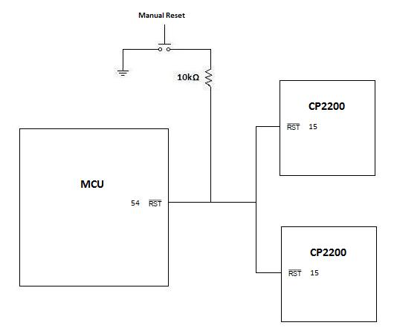
Figure 2.4.4.1: Manual Reset Subsystem

2.4.5: Programming Module Port
Freescale, the manufacturer of the MCU, recommends programming and debugging the MCU with a Cyclone Pro Programmer module. Although this module is prohibitively expensive for the design group, the project sponsor has a unit on hand and so the group will plan on being able to use it. The way that the programmer interfaces with the microcontroller is through a 6-pin background debug mode (BDM) ribbon cable that can also be used by other programming modules compatible with the MC9S12XDP512, just in case the Cyclone Pro is unavailable to the group.
A female BDM port is built into every microcontroller. In the protocol converter, the port will be placed up against the casing and an opening in the casing will be bored so that the port will be available to the user. Figure 2.4.5.1 details how each pin will be connected to the MCU.

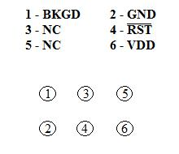
Figure 2.4.5.1: Reference guide and BDM pins as seen facing female end

2.5 Case
The case was given no specified size by MPE. The design team was instructed to wait until the PCB was manufactured and that a metal case would be manufactured to fit it. Figure 2.5.1 gives a mockup of what the completed device might look like.

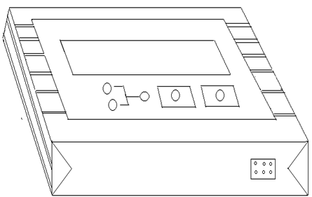
Figure 2.5.1: Case from front/top

The converter will have two ports for the Ethernet connectors that will be located at the rear of the housing. A BDM port will be placed at the front of the housing for any debugging device that is compatible. The color of the case will be black simply because this is standard color for circuit board cases, and the black paint will be mixed with a protective substance to provide a shield layer. It will be coated along the surface of the case to act as an electromagnetic shield.

The rear view of the converter shows more design details:
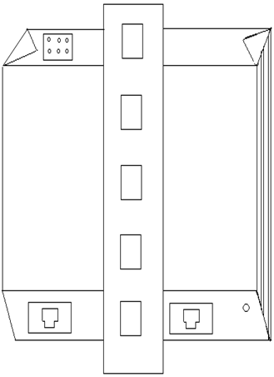
Figure: 2.5.2: Isometric view from behind

A DIN rail connector must be attached to the device’s housing. The main power source will be enabled whenever the circuit board is connected to the DIN rail mount. The case will be tested for different environmental conditions including heavy water spray. Some component schematics call for a chassis ground. The metal case itself will serve as the chassis ground, but it must be connected to the PCB power layer so that no voltage difference builds up between the case and PCB. This will be achieved via a bolt or screw. The housing also has the unique function of managing temperature. Vents are the main feature of the housing that was added to the sides of the case to allow air flow to circulate in the circuit board area; the design team decided to add vents to the casing simply because some components will produce heat. The vents will remove the heat produced to avoid overheating or other mishaps.

3 Software Design
3.1 Modbus Protocol
In the scope of our design project, the first thing that’s in order is a basic understanding of how Modbus TCP works. Modbus was designed in 1979 for industrial automation and was then adopted as an industry standard to control most SCADA systems. It is built around the principle of master-slave (client-server).
The master-slave model is one where many slave devices connect to one master. See figure 3.1.1 for illustration. The model allows for requests to only come from the master with responses being supplied by the slave devices.

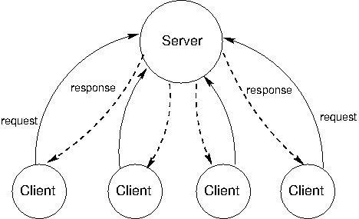
Figure 3.1.1: Master-Slave (Client-Server) Model.

In Modbus the master device can communicate with each slave device individually or it can communicate will all slave devices at the same time. The way the slave device determines if the master is communicating with it or not is by the broadcast address or slave address and the function code, which determines what the requested action is. Figure 3.1.2 illustrates how the data stream is configured on Modbus TCP. Figure 3.1.3 shows how each of the data stream fields are populated and what is in each field.
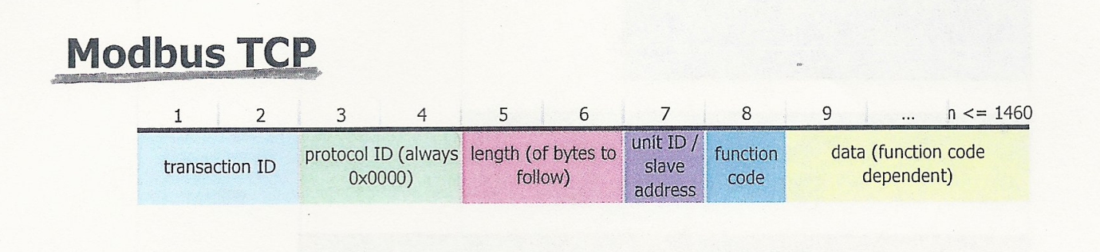
Figure 3.1.2: Modbus TCP Data stream
Reprinted with permission from MPE

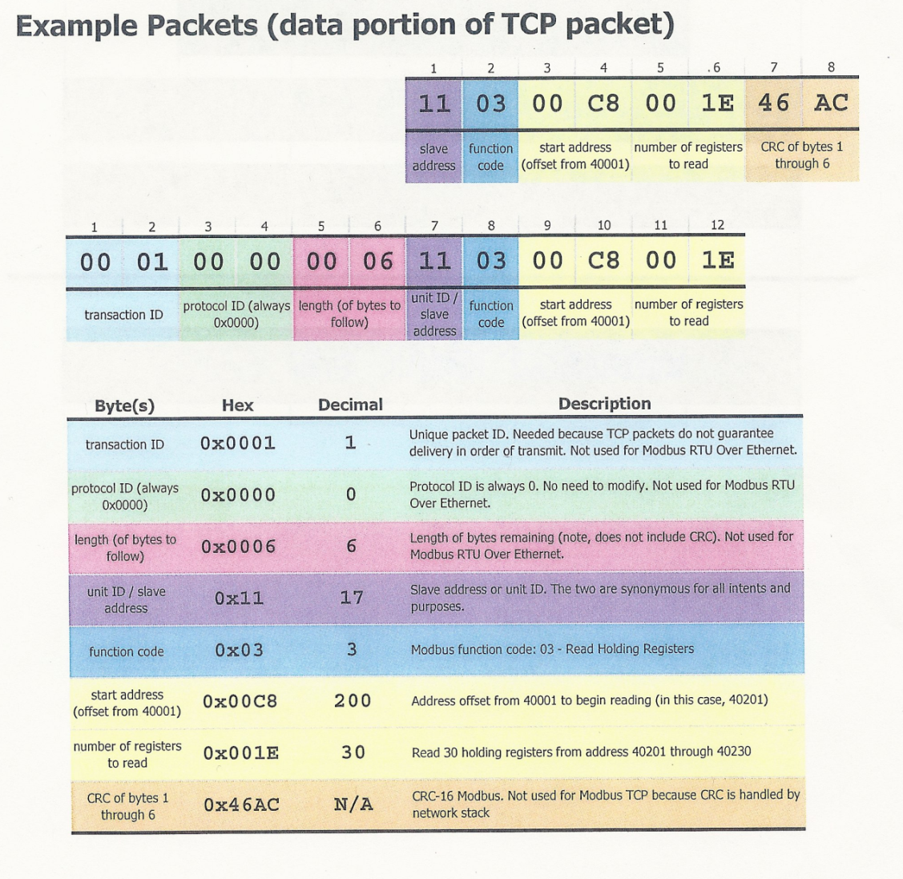
Figure 3.1.3: Example of Modbus TCP data stream and definitions
Reprinted with permission from MPE

Modbus TCP is based around two different layer models the OSI 7-layer model or the 5-layer TCP standard. For the purposes of this project the team is using the 5-layer TCP standard model. Figure 3.1.4 shows how each the model works. It’s a top down model where the Modbus data stream is the application layer consisting of no more than 1460 bytes. A 20 byte TCP header is attached to control and ensure reliable data routing in the transport layer. The network layer adds another 20 byte header for the IP address (source and destination). The final layer that adds information to the data stream is the data-link layer. A 14 byte Ethernet header is added before the data stream and a 4 byte checksum is added to the end of the data stream.

Figure 3.1.4: Modbus TCP 5-layer model
Re-printed with permission from MPE.

The Modbus protocol supports many function codes, and it was determined that the device only need to support a few of them. Table 3.1.1 lists all of the needed function codes to handle any of the Modbus protocol utilized in this device. This gateway device will primarily use function codes 01, 03, 04 and 06. The device will not need to read or set coil values.

Function Code | Function Description | Notes
01 | Read Coil Status
02 | Read Input Status
03 | Read Holding Registers
04 | Read Input Registers
05 | Force Single Coil
06 | Preset Single Register
08 | Diagnostics – Sub-function 00( Return Query Data
15 | Force Multiple Coils | Limited to 100 coils
16 | Preset Multiple Registers | Limited to 35 Registers
Table 3.1.1: Modbus Functions. Information provided by MPE.
3.2 DNP3 Protocol
DNP3 protocol has been used for many years in the electric utilities market and is now beginning to transition into the wastewater utilities. This shift is what brought on the need for a protocol converter. DNP3 goes beyond the old architecture of master-slave and allows for a master-master relationship. Having a device that is able to communicate with the central command center as well as receive communications from the central command center is invaluable. The new standard allows managers to effectively fix problems as they develop instead of waiting until the next polling event. Table 3.2.1 shows a listing of the function codes available in DNP3.
The increased functionality of the DNP3 language is one of the benefits over Modbus. Another is the use of security objects. The security objects are hex values imbedded into the DNP3 data stream to only allow the DNP3 devices to receive and translate the message. This was added due to DNP3 allowing for wireless transmitting and as a security measure to combat attackers from gaining control of vital utility systems.

Function Code | Description | Meaning
0 | Confirm | Used in requests and responses
1 | Read | Respond with data objects requested
2 | Write | Store objects and respond with status
3 | Select | Pre-arm control point
4 | Operate | Carry out action on selected point. Respond with status
5 | Direct Operate | Select and operate control point. Respond with status
6 | Direct Operate, no Ack | Select and operate control point
7 | Immediate Freeze | Copy specified objects to freeze buffer. Respond with status
8 | Immediate Freeze, no Ack | Copy specified objects to freeze buffer.
9 | Freeze and Clear | Copy specified objects to freeze buffer, then clear objects. Respond with status
10 | Freeze and Clear, no Ack | Copy specified objects to freeze buffer, then clear objects.
13 | Cold Restart | Respond with time to availability, restart application
20 | Enable Unsolicited Messages | Enable unsolicited messages. Respond with status
21 | Disable Unsolicited Message | Disable unsolicited messages. Respond with status
22 | Assign Class | Assign Specified Data objects to class defined by class object headers preceding object identifiers. Respond with status
23 | Delay Measurement | Turnaround message. Include processing time in message so that master can calculate message travel time excluding outstation processing time.
129 | Response | This indicates that the message is a response to a request.
130 | Unsolicited Message | This indicates that the message is an unsolicited response.
Table 3.2.1: DNP3 function code
3.3 Development Environment

The choice of which development environment in which to code ended up being a bigger decision than originally planned. The right coding environment is critical to be able to get the code optimized and running correctly on the microcontroller. There are a multitude of coding environments out there and they all have their perks and features but they also have drawbacks. This section will outline the different coding environments the software design team considered, why they were considered, and the conclusion that was reached.

The main goal was to find development environment that would take C coding language and convert it to the assembly needed for the microcontroller. The first limitation the team ran into is that the project sponsor was dead set on using a Motorola microcontroller because that is what all their other products use. Now when researching assembly development environments it was found that there are quite a few low priced or free ones that were appealing, however on further inspection it was found that most were for TI or Intel chipsets. In fact, Motorola environments were in general, quite a bit harder to find then TI or Intel compatible environments.

Most of the development suites that are combatable with the Motorola microcontroller reviewed by the software design team either lack features or are extremely expensive. The one that looked the most promising was an environment called CodeWarrior Development Studio. It had all of the features the team wanted, was able to code to the HCS12(X) family, and can optimize code specifically for it. This development studio allows one to build up a microcontroller quickly and efficiently. However, at the time, all the team could find was the professional suite, which was quite a bit out of the project’s price range.

When the team first hit this stumbling block it considered using gcc to compile the assembly code. After quite a bit of research, it was found that while it would work and would be monetarily cheaper, the code would not be even close to optimized and it would also be a very roundabout method. Taking the amount of coding that has to be done on this product the team quickly realized that this was not how it should be compiling the project code. That being said this is a valid method to programming this chipset and if you have the time and patience. The team was then told that the industry standard for coding the Motorola chipset was the CodeWarrior Development Studio.

It was decided that CodeWarrior deserved a second look. After talking with one of their sales reps the team was pointed back to the site and found that not only did they have all the features needed for the project, they also provided different suite packages, depending on the amount needed to program on the chip. Everything from a free trial to a professional suite that was quite pricey. Initially the team had planned on trying to use the trial suite but figured that it was going to exceed the amount allowed to be coded on it, so it had to upgrade to the basic suite. So in conclusion, if you are programming a Motorola chip, first off if you are an electrical engineer, talk to a computer engineer, and secondly, you should consider the CodeWarrior Development Studio. It is by far the suite best designed to handle the Motorola microcontrollers.

3.4 Software Life-Cycle

The software development process is integral to designing and maintaining any software. The design team had to consider multiple life-cycles and figure out which best fit the product. This section covers which life cycles were considered, why they were considered and finally, which was chosen.

The first development process that came under consideration was the V-Model. The team chose this first because it figured it would be similar to the waterfall model, with some improvements. In the figure 3.4.1(below) you can see the general flow of the life-cycle.
The V-model is apparently a good one to use because it breaks down the work into parts that match up quite well with the timeline generated during the project’s initial documentation. After trying to apply it to the schedule of work, the design team ran into a couple of problems.

The largest problem the team hit was that according to this model was because of the design timeline of this project with the hardware versus the software a lot of the testing was not able to be followed. While having all the test designs and testing is preferable, so you can measure twice and cut once so to speak, the time given for this project just did not permit the use of this method.

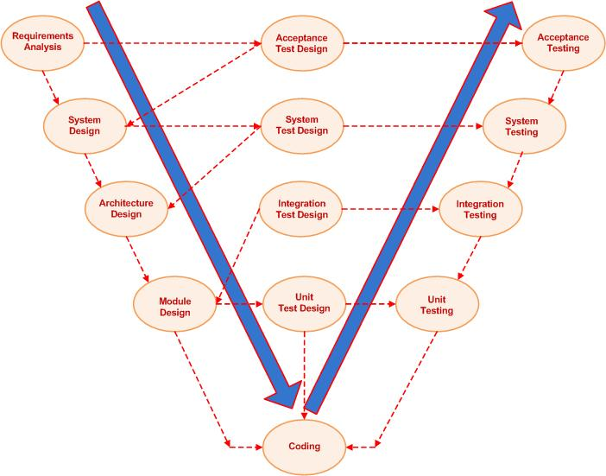
Figure 3.4.1: V Development Model
Re-printed under a creative commons license

Since the V-model didn’t work as well as the team would have liked, it went with another standard life cycle known as the spiral model (pictured below in figure 3.4.2). The team figured it would be an improvement over the V-model because it featured a little less testing. Naturally, it had to be fitted to the project timeline. The figure below is inaccurate in the fact that there will be only one prototype, but other than that the general flow was very similar.

No member of the team was overly familiar with designing while using these life cycles, but the team felt like this one still had a pretty major flaw solely based on time constraints. The team liked that it was a simple life-cycle that would allow us to have a nice plan set out without taking up too much time just testing and redesigning. While this seemed like it could be the life cycle to use, the team also felt that more research into life cycles needed to be done just to make sure nothing was a better fit for our project.

The main drawback in this was how the prototyping was done multiple times. The team felt that that the timeline only allowed for one prototype. Now that does not exclude this life cycle because you could still use this process with only one prototype and it would probably just end up with a product that was not as polished. This worked ok for because the team goal was not to have a polished product but a functioning one. So while overall the spiral model could fit the project, the team would try to fit some more recent development processes to its timeline for a better fit.

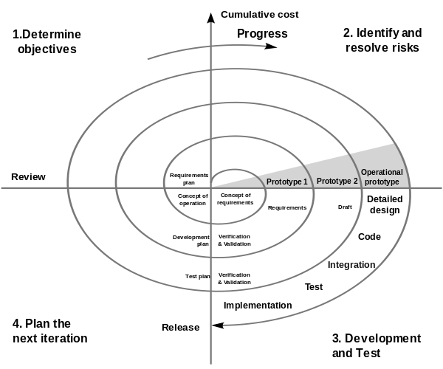
Figure 3.4.2: Spiral Development Model
Re-printed under a creative commons license

Because of the spiral model didn’t look like it would fit the project like the team would have liked, it was decided to look at the agile development model. No one on the team was familiar with this model but some members had heard it was a very popular model, so an attempt was made to apply it to our project. One of the main draws to this method was its constant praise it received for producing the final project faster by having very strict planning phases but being able to adjust to issues quickly, daily check-ins, prioritized lists, etc. The tried to line up the project timeline with the general agile software development model and again ran into quite a few problems.

The major issue it had was that it seemed like there was too many managerial steps in it for such a small group. While the team really liked how it promoted adaptive planning and how it was based off the iterative and incremental life cycle, it just had too much in it. A different direction was needed to simplify the life cycle. Although this cycle could work well, it just seemed like it was meant for a larger scale project that both had more people working on it as well as needed to manage a schedule over a larger amount of time. With a small group and not a lot of time in which to develop, it was concluded that simpler would be better.

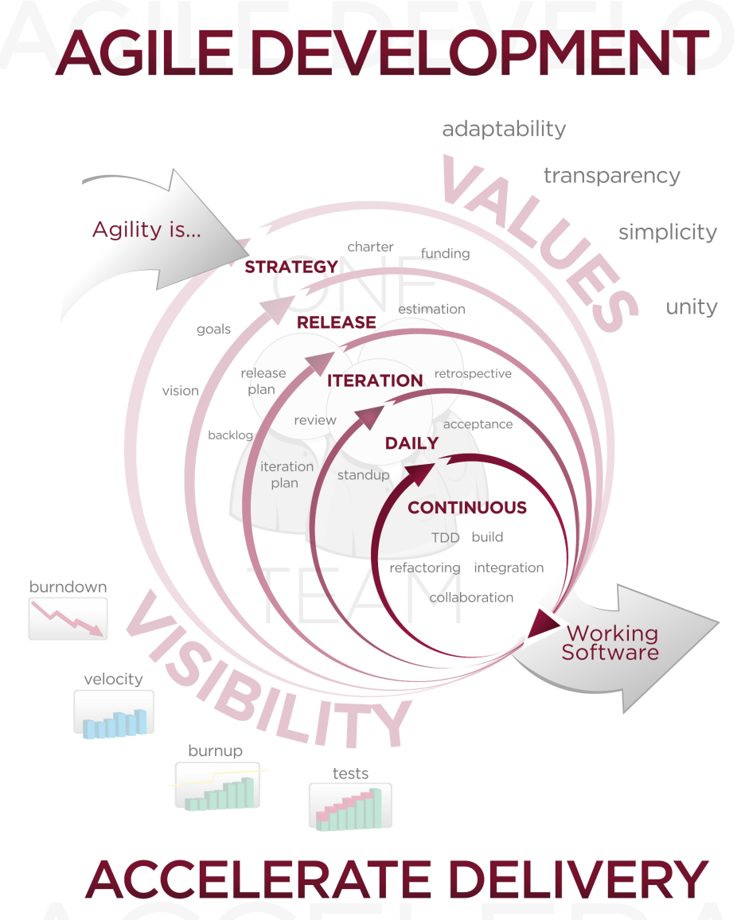
Figure 3.4.3: Agile Development Model
Re-printed under a creative commons license

Seeing as the decision was made to go simpler the obvious next software development cycle to consider was just the iterative and incremental life cycle (pictured below in Figure 3.4.4) or a basic waterfall method (pictured on the next page in Figure 3.4.5). Both of these cycles are as basic as they come and most models are based off them. The team figured it would start with the more thorough method that would provide a little more testing.

Using the iterative and incremental model would be quite simple. All that was needed to be done was a basic design process and prototyping followed by testing, then going back through the software to see if more than one iteration of the program was needed. The team figured this would be the method for a while until it started really thinking about what the project entailed.

Realistically the main job on this project was to get a functioning product to MP electronics and they would keep it up to date with what they needed. So did the team really need the cycling, or did it just need a direct path to deployment like in the waterfall model? There was no need to backtrack through the model once everything had been implemented. At this point, the team’s attention was turned completely to the waterfall model.

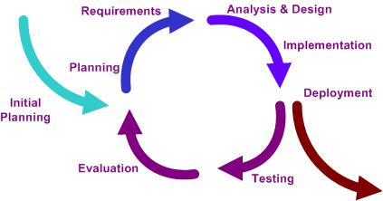
Figure 3.4.4: Iterative and Incremental Life Cycle
Re-printed under a creative commons license

At this point the group had decided that the waterfall method was the correct model to use. First off, it was a simple enough design process that wouldn’t slow down the development of the product by constant testing every step taken and yet it still provided a nice outline and flow overall. The team could follow the waterfall life cycle step by step up to the maintenance portion, which is where the project sponsor, MPE, would take up the helm.

The fact that this model had sequential progression through its steps allows the team to easily work through the design process. While generally this method is considered more for hardware, the team found that it would fit this project quite well solely on the time crunch factor. The team would not have the more than 4 months to code all the firmware for this project. The thought that anyone would have a working model and it would need an improvement in four months is just unrealistic. After that time frame, MP electronics would have the product and the design team would not even be involved with it anymore. The other perk of using this model is it was very easy to integrate into the life-cycle of the project overall, which had a lot of hardware design too. The team wasn’t even able to start the process until the hardware had been designed anyways so it ended up connecting the software life cycle between the design and the implementation portion of the hardware design and then connect the two at the verification step.

For the “requirements” stage the group sat down once the hardware was designed and wrote out what features needed to implement to make the controller function at basic levels. In addition to the features we had to work out the limitations of both the hardware itself, as in how many resources we had at our disposal and the limitation of our development environment.

The “design” stage of this project will be covered more in-depth in section 3.6. However to give a brief overview of what was done, the group met and did a very high level design of just how the general features would interact. It then took each of those elements and started working mid-level design by going through and writing each function it wanted to implement in pseudo code and drawing up UMLs.

At the time this paper is being written, the team is preparing to head into the “implementation” stage of the project. This stage will involve taking all the UMLs previously designed and going through and coding them, as well as testing their functionality in the coding environment. The “verification” stage will take place once the team is actually connecting and loading the firmware onto the microcontroller.

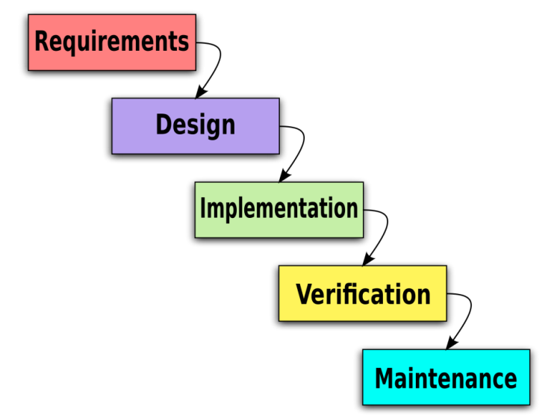
Figure 3.4.5: Waterfall Life Cycle
Re-printed under a creative commons license

3.5 Information Flow
Data in the gateway device has a complicated path to follow. The path data flows will come from one of two directions. It will come from the Modbus slave device to the gateway and it will come from the master DNP3 controller to the gateway.

Figure 3.5.1: Modbus Information Flow

Data in the Modbus data path has a manual and automatic data handling flow. Starting from the Modbus slave device data is sent to the gateway and stored in the specified registers. This will be a continuously updating stream. The time between updates will be set by the user using the display. As each register is updated the gateway will check if the previous register value and the current value are the same. If they are the same then it will move to the next register and repeat the process. If no changes are found the cycle timer will be reset to 0 and the counter will begin until the next register reading.
If there is a change, the gateway will immediately flag a change. It then will record the register that is showing a change, record the date and time. Once recorded it will be saved to the MCU’s flash memory and will send a signal to the DNP3 information stream to be readied for delivery to the master control center. After the data is passed to the DNP3 information stream the reading/checking of registers on the Modbus stream will be resumed.

Figure 3.5.2: DNP3 Data stream

Data coming from the DNP3 master or control center will be in the form of a polling request or other information gathering requiring a response. The request coming from the master will have the control id indicating which device should respond to the request. First the gateway will remove this id as it will be handled by the first DNP3 receiving device. Once removed the data will pass through the DNP3 decoding function. The function will handle the decoding of the security objects and validate the data stream.

After the data is validated by the security decoding the data is broken into parts and converted into Modbus protocol. It was found to be easier at this stage to change from DNP3 to Modbus for data manipulation and comparison. The data conversion will take place over a specified register range as to avoid any data loss or mix up. Once the data has been verified that conversion occurred, and no data was lost two functions are called. The first is to sync the date and time with the master controller. The second is to call the Modbus comparison function in the Modbus data stream. This will supersede the timer and check for any changes. If no change is found an all clear code is transmitted back to the DNP3 data stream. If a change is found it will follow the path in the Modbus data stream to report the change and send the appropriate error code.

Once the checking is completed the prepared the message is then send into a function to convert Modbus to DNP3. Using a designated set of registers to perform the data change, and verification function is called to check for any lost data. After passing the verification the stream is sent to the security encoding to add the correct security objects for validation at the main control center. Once completed the device id is added back to the stream and it is released back to the DNP3 device for transmission to the master control center.

The gateway device is responsible for maintaining two separate data streams and making each stream communicate with the other. After the research done on the MCU it was found that this was the best way to handle the way data flows throughout the device. Having a single data stream that handled all of the manipulation was found to be tedious when working with simple requests such as date and time sync.

3.6 Code Design Process

The coding design process can be slightly frustrating at times and while most students don’t like to do it, in the end it will increase your coding efficiency greatly. This section will cover the design process as far as the software is concerned. The design process is broken down into four stages. These stages consist of a planning, a high level design, and a lower level design, followed lastly by implementing the code in its development environment, and then testing.

In the planning phase, our team had three main goals, a rough idea of features, a basic timeline, and a life cycle. The designing of the features was interesting exercise because it was the first thing done as far as the programming goes and it was on a topic no team member was familiar with: DNP3. Because this was a sponsored project and they already had a general idea and list of features they wanted the initial step was to set up a meeting with them and get a better idea about what they wanted. This proved to be somewhat fruitful because while they couldn’t help much on how to tackle the programming portion of this project they did have all the requirements that the device would need as well as some of the features they would like. This provided a good starting point for the software designers; MPE also had a book on DNP3.

After further research on this project and reading the book, the team figured out two things. First, this project was quite a bit different then had been originally thought, and second, the DNP3 book was incredibly lacking. This set the team back slightly but because it had to wait on some of the hardware to get done before it could get too in depth with the coding, it wasn’t so bad. However, the team decided that a timeline needed to be created to keep the coding on schedule with the rest of the build. The timeline pretty much was designed to break down when each of the stages would start and when the team wanted them hopefully finished by. It also broke down each phase into the parts so the team would have a better concept on what actually needed to get done. After the timeline was done, the team set off on researching more because the lack of prior knowledge on this topic was determined to be the biggest hurdle in the coding.

After the group felt like it had a comfortable grip on what the project actually entailed in addition to the list we received from MP electronics, it was able to construct a set of features that would need to be included to make the product function how the client wanted. After the timeline and the features were determined, the team moved onto picking a development life cycle, which is pretty much version two of the timeline. Now this decision ended up being a very difficult choice, because there were a lot of factors about how far the team would take this product in its life. The thought process behind that choice is covered in section 3.4 of this documentation in more depth.

Now that the planning and a lot of the research were out of the way, the actual design needed to start. The first thing tackled in the high level design was the information flow. The team went through its list of features and designed how the Modbus and DNP3 sides would need to communicate to make them possible. You can see the flow in section 3.5. The flow you see there is the main function of the program. The software is designed to have the DNP3 controller as the master and slave the lift station’s default communication device. To help you follow the design process, the following couple of paragraphs will briefly describe the high level information flow of the system. The software for this project was designed in two sections. One part of it handles the Modbus side and the other one handles the DNP3 side.

The Modbus side of the programming effectively slaves the current communication device on the lift station. This portion of the code is mainly to retrieve error codes. It is made so that it will check for errors on a set time cycle as well as whenever the client decides to ping the DNP3 controller. At this point the controller will check for a register change. If none is detected, it will report back all clear. If there is one, it records the date, time, and error code and sends a signal to the DNP3 controller and stores the data in the Modbus registers.

This brings us to the coding that handles the DNP3 side of the controller. This side handles the conversion of DNP3 to and from Modbus. That process allows for talking to the slave and retrieving the data stored within. The other task this side handles is the security encoding and decoding. DNP3 has an inherent security that needs to be broken down and built up to use, so this code will also handle that.

Once it was determined how the data was going to transfer back and forth, the team was able to start dissecting it down into low level functions. To do this, a meeting was called to sort out all the functions that would be used to accomplish each task on the information flow and figure out what each one would include. This is a lengthy task in the overall design process but it ends up saving you time later when you sit down to code, especially when you have programmers that are not comfortable with the subject matter. Because of this, the team felt it was a critical part of the software design process.

The functions are broken down using flow charts; you can see them in section 3.7. The team drew these flow charts to contain all the necessary information one would need to code them. Included are the function names, what their task is, what other function they link to, etc. Once they are broken down to this point all that’s left is to hard code them.

Having the functions to this point allowed for a great deal of flexibility with the coding. The team decided the best way to handle this would be to give most of the work to the computer engineers but give some of the simpler functions to the electrical engineers so they could experience the coding environment (Freescale CodeWarrior) as well as just have something to do later in the project because the hardware would be done quite a bit before the software.

The testing is the final step in the design process. In brief, the testing was designed to ensure that data was flowing back and forth correctly. This process is covered in depth in section 6.2.

3.7 Flow Diagrams
3.7.1 Data Change from the Modbus Side
This flow diagram shows how the data will flow through the functions on the Modbus side of the program. There are two ways that the Modbus device can be triggered: first is the EventTimer function (3.7.2), which is just a clock that counts down a set amount and at zero it parses the device and resets the timer to its initial amount. Second is from the Check Modbus function. This function is called when the master device wants to parse the slave device at a time that is separate than the set timer. When this happens, it will also reset the EventTimer to its starting amount.
After the signal is received to parse the device, the program will run the Get RegisterValue function, which retrieves the current values stored in the registers on the slave device. The register addresses of the values that are checked are passed into this function. Once this value is retrieved, it is stored as NewValue for use in CompareValue function. The CompareValue function is called to compare the NewValue and the StoredValue. If there is a change then an error has occurred or has been fixed and the event needs to be recorded. The first step of that is to call the SetRegisterValue function, which takes the RegisterAdress and Value of the change and passes it through to the Record Event function, which will be explained in section 3.7.3. From here the process needs to be repeated for all valid registers.

Figure 3.7.1.1: Data Change from the Modbus side

3.7.2 EventTimer
The EventTimer function, shown in the following flowchart, is a critical function for the program because it is used to control the automatic parsing of the Modbus device as well controlling the timer in general. If you follow the data through the flow you can see how the function actually works. EventTimer is called every time the Modbus Device is parsed. It’s called to assure correct time stamping of the data that was stored.
So once the function is called the first action is to get the SystemTime from the master device. This value is then checked against the time of the device. If it is correct, it reports all clear and allows the function to continue as intended. If there is an error, the device will update its timer to match the master device and then it will allow the program to continue as intended.

Figure 3.7.2.1: EventTimer
3.7.3 Record Event
The flow covered in this section is the function that is actually used to record all events that get stored in the flash memory. This was an important requirement put in place from the sponsors. This was a giant flaw of the Modbus device that is currently in place, causing dropped connection and the loss of all the events that had taken place in between polling. This function controls not only the registering of the events but the count as well.
RecordEvent takes the time, register address, and the register value from the Modbus Slave, formats them with timestamp, and stores the result in the flash memory. This will allow the data to be saved even if there is an event like a power outage. This data is stored in a linked list that can store slightly over twenty thousand events. The reason it was decided to go over twenty thousand events was to avoid out of bounds errors.
The other safeguard against the program going out of bounds is the CheckEventCount call that is part of the RecordEvent function. After every record event, the function will check the current amount of events stored. If the count is over twenty thousand, then it will delete the oldest event and then send the error to the master device. If the count is under that then the error is immediately reported to the master. Sending the error to the master (3.7.4) will be discussed in the next section.

Figure 3.7.4.1: Record Event
3.7.4 Send Error
The flow diagram that follows is the SendError function. This function will take the event data that was just stored and send it to the master. While the data flow itself is simple, the actual task of this function is a little more complex. The actual error is just a value on a register, so this function will take the value and compare it to a table of error codes and their corresponding error values. It will then take this error code as well as the timestamp and send it to the master device. To get this information to the master device it will need to send it through the ConvertToDNP3 function (3.7.9).

Figure 3.7.4.1: Send Error

3.7.5 DNP3 Decode
In this flow you can see the DNP3 Decode function. This is half of the main feature this device is being designed for, the other half being the encoding. If you refer back to section 3.1 and 3.2 you can see the major advantages that exist by using the DNP3 protocol over the Modbus. The main task of this function is to take apart the DNP3 signal from the master device and make it understandable for the Modbus slave to understand. This task is accomplished by this function and the ConvertToModbus function (3.7.6).
To start, the data is received from the master device. The first step to taking that data in is comparing device IDs. This is handled by the CompareDeviceID function. The purpose of this function is to determine which station they want to parse. There are multiple devices hooked up the system, and each device has its own unique ID. This allows the user to input that ID into the data so that instead of going through and polling every device in the system, they can select which systems they want to interact with.
DNP3 protocol has a header on it that needs to be removed to be processed further to be converted, so the next step of the DNP3 Decode function is to remove that header. This leads to security encryption that is native with this protocol. This function handles this security feature in two ways. First, it checks the security value, to make sure the access is authorized, if it’s not, it will create a security error. This error, like all the other errors, will be reported to the master device. If the security check clears it is then passed to the function that handles the actual data conversion.

Figure 3.7.5.1: DNP3 Decode

3.7.6 Convert to Modbus
The convert to Modbus function purpose is to take the data from the DNP3 decode function and break it apart into each data sub-entry. It will take the data stream and break it into 16-bit subsets and store them in a temporary register. From there the data will be accessed register by register and sent through a conversion algorithm to change the values to match the Modbus protocol. After the algorithm loop is run for the entire DNP3 data stream the convert to DNP3 function is called to verify that that data has been converted correctly. If an error is found then the original data stream will only re-run the data that did not pass verification.

Figure 3.7.6.1: Convert to Modbus

3.7.7 Sync Date/Time
The function shown here is how the device sets its clock. The Sync Date/Time function can receive its input from two different sources. First, it can retrieve its time from the master device. This process will happen every time the data is polled from the master. It will get the time from the master device; check the slave device’s time against the master’s and if there is a difference it will set the slave device timestamp to match.
The other input method is from hardware side of the controller during the initial setup. There is a display on the board with some buttons, these buttons are used to navigate the menu system but during the initial setup of the device they can be used to set up the clock.

Figure 3.7.7.1: Sync date/time

3.7.8 Check Modbus
The purpose of the CheckModbus function above is to ensure that the data is in the correct format before it is sent to be converted back to DNP3. The purpose of this function is to check formatting of the data that is produced by the device. This is to avoid errors from data being formatted incorrectly before the conversion to DNP3.
This function takes the updated timestamp and the InputData, which in this case is the register address and the error value and then formats it to the correct form. The next step checks the data form and sends it out to be converted in the ConvertToDNP3 function.

Figure 3.7.8.1: Check Modbus
3.7.9 Convert to DNP3
Convert to DNP3 is a mirror of the convert to Modbus flow. The data stream sent from check Modbus or from the send error functions is stored in 16-bit blocks. Each block is passed through the convert to DNP3 algorithm and stored in a separate register. Once the entire stream has been converted the convert to Modbus function is called to verify the data conversion was successful and accurate. If no issues are found then the 16-bit blocks are put back together and the data stream is sent to DNP3 encode function. If an error is found then the Convert to DNP3 algorithm is re-run on the error block to attempt to fix the incorrect conversion.

Figure 3.7.9.1: Convert to DNP3

3.7.10 DNP3 Encode
The function displayed below is the final part of the conversion process of the Modbus protocol to the DNP3 protocol. It takes the formatted code from converted data from ConvertToDNP3 function and encrypts with the security values. After the encryption in complete it adds the standard DNP3 header back onto the data and sends it to the master device.

Figure 3.7.10.1: DNP3 Encode

4 Design Summary
4.1 Hardware Design Summary
The hardware circuit design is professionally done. As stated before, Motor Protection Electronics reviewed all of the schematics created using Eagle Software. Some adjusts had to be made to the circuit design but overall the design was approved. The design team received recommendations from the Motor Protection Electronics engineers on how to improve circuit design, which will cut cost for parts. The design team is grateful to have the resources that were given to make the project successful. Initially, the sponsor made it clear that the power supply and proper grounding are important factors that will determine whether or not the device will be successful.
4.1.1: Surge Protection
The surge protection circuit is the gateway for the circuit design. Its main function is to protect the circuit board from any irregular power conditions, voltage spikes and other abnormal power conditions. Two surge protection component were the primary components that makes up the surge protection circuit. The design team connected those two components in a shunt configuration because that method is more effective in that position. The surge protection components were initially placed in a blocking configuration. After testing the circuit in this manner, the design team noticed that unwanted voltage still manage to escape the surge protection components and the excess voltage leakage went on to supply the components which makes up the circuit design. As a result, the design was modified to allow the surge protection circuit to overcome any obstacles that stand in its path. According to the results that were taken during the simulation process, the maximum voltage the surge protection circuit can withstand is 40V.
4.1.2: Reset Sources

During the initial meeting, the project sponsor made it clear to the design team to have resets available for the circuit. Fortunately, the microcontroller, Ethernet controller and clock had the reset sources as a feature. However, the design team wanted all of the components, which has the reset feature, to synchronize with each other. Furthermore, any device that is connected to those components should also be placed in the reset state. In hardware testing section, many tests were done to ensure that once one the component reset is activated, the entire circuit board will be placed in the reset state. The reset sources that are relevant to the circuit design are the Power-On Reset, Low Voltage Detect, and Oscillator Fail Reset. It should be noted that the reset option is crucial to the circuit design. The project device will be in the area that has Electromagnetic Inference present; therefore this condition will not interfere with the device’s field performance. The resets feature is also great because whenever any device goes into the reset state, the information that is temporary stored in the registers is not tampered with.
4.1.3: DC-to-DC Converter

The DC-to-DC converter circuit is working up to par. The switching and linear regulator went through plenty evaluations to see which one can produce the most for the circuit design. The linear regulator was not chosen simply because too much power will be lost which the circuit board needs to function. The design team was pleased with the switching regulator’s efficiency and productivity. Also the manufacturer allowed the design team to use their example circuit as a reference. Ample time was saved due to the generosity of the manufacture. The manufacture example circuit was tested to see if it met all of the requirements needed for the circuit design. As a result, Rohm’s example circuit exceeded our expectations and it was used as the DC-to-DC converter circuit. One remarkable feature from the example circuit is that the resistor can be adjusted to output the specific voltage desired for components on the circuit board. The output voltage from the DC-to-DC converter circuit supplies all of the devices on the circuit board that requires power supply.

4.1.4: Case

The circuit board housing will be manufactured by Motor Protection Electronics. One of the requirements for the case is it needs to have a DIN rail connector so it can be connected to a DIN rail mount. The housing will have a chassis ground mounted on because some components pins has to be connected to it. Also, the ground plane needs to be connected to the chassis ground, this technique helps with removing Electromagnetic Interference. Considerations were taken into account to permit the housing to be easily dismantled if an incident occurs, which will result in one of the circuit board component needing to be replaced. The housing was designed to withstand any weather and temperature conditions. The color chosen for the device housing, which is black, does not have an influence on the device performance; however, it is the standard color for circuit board housings. The material used is plastic because it is considered to be durable and most efficient in its class. Vents were added to the sides of case to prevent overheating and remove the heat being created by components on the circuit board.

4.1.5: Power Supply Subsystem

The power supply subsystem consists of two circuits, which are the DC-to-DC converter and Surge Protection Circuit that cooperate with each other to supply all of the components on the circuit board that requires power. Its main function is to ensure that irregular power conditions do not affect the device performance and constantly distribute power to the circuit board. Figure 4 shows an illustration of the power supply subsystem.

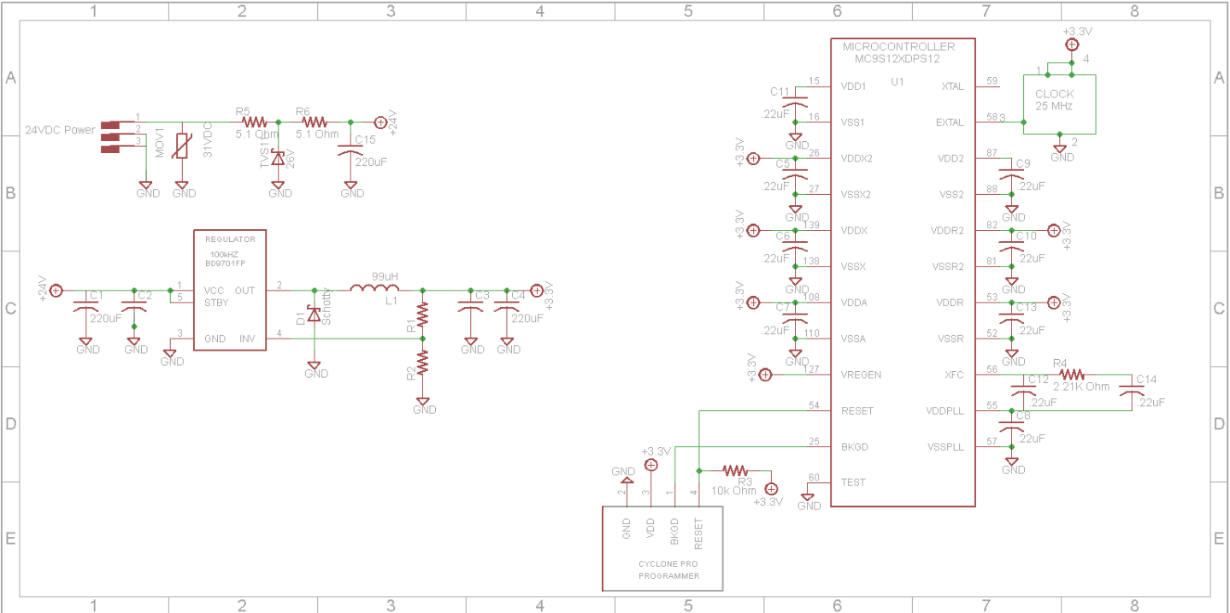
Figure 4.1.5.1: Schematic of Power Supply Design
4.1.6: Ethernet Interface Subsystem
The Ethernet interface subsystem is what allows the device to communicate with the network of pump controllers. The design team has taken advantage of RJ-45 Ethernet jacks that include an interference module within so that no further EMI protection needed to be included in the hardware design. These jacks will interface with two Ethernet controllers which themselves interface with the MCU. One controller deals entirely with the Modbus input network transmission and the other controller deals entirely with the DNP3 output network transmission. Power and reset pins from the MCU will be tied directly to those on the Ethernet controllers.

4.1.7: User Interface Subsystem
The user interface allows the operator to view and change parameters pertaining to network transmission, program the MCU if need be, and reset all hardware subsystems manually. Three active-high push buttons allow the user to scroll up, scroll down, and toggle between ‘Value Change’ and ‘Menu Scroll’ modes. The active mode is indicated by a pair of LED lights. A manual reset subsystem will tie the reset-not pins of the MCU and Ethernet controllers together and connect to a push button which will drive those pins low when depressed. A background debug mode port is built into the MCU. This will be connected with the microcontroller’s reset-not, BKGD, and VDD pins as well as the ground plane. The port will be placed against the casing and a hole bored through the casing will allow the operator to access this port.
4.1.8: Hardware Design Diagram
The following diagram illustrates the interactions between the various hardware subsystems with key details indicated.
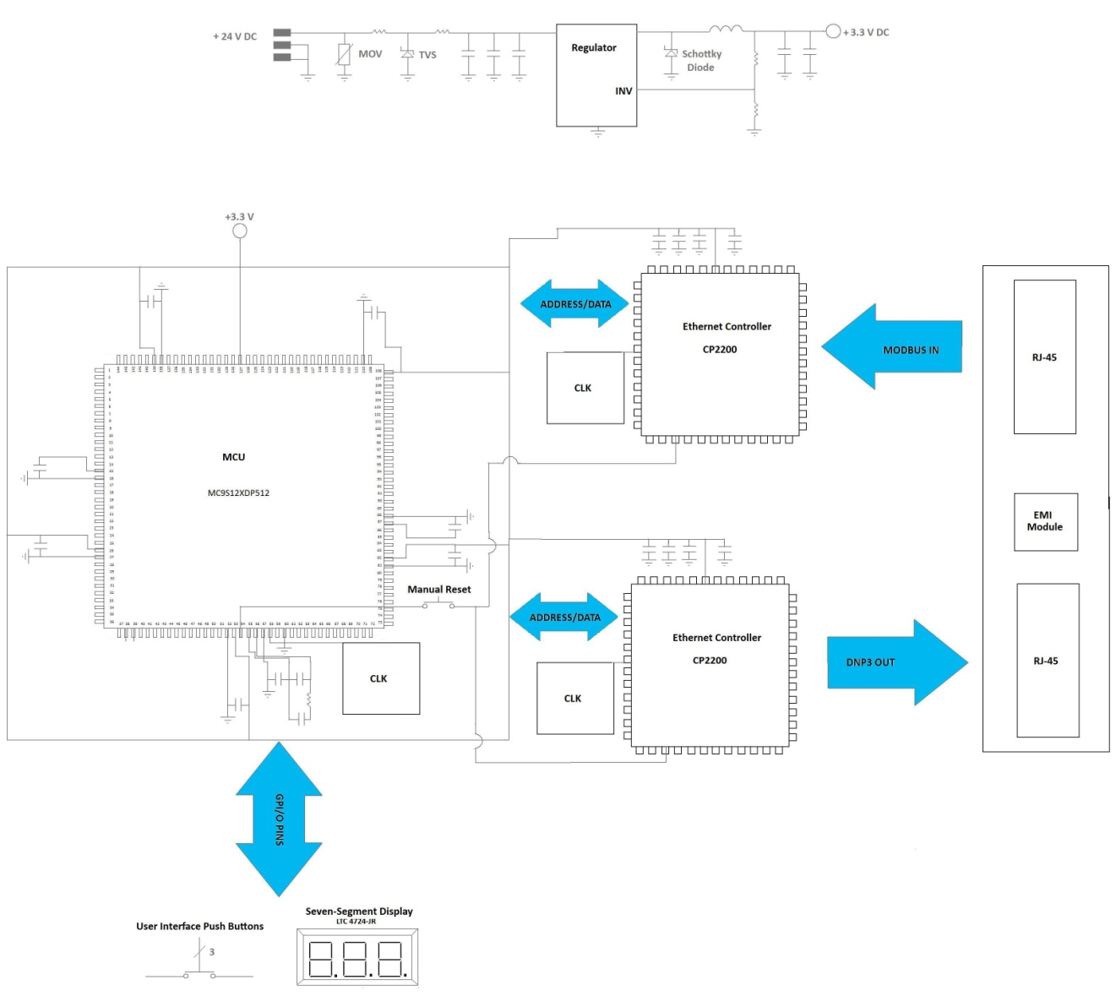
Figure 4.1.8.1: Hardware Summary Diagram
4.2 Software Design Summary
This device is designed around two SCADA protocols, Modbus and DNP3. Modbus was considered an industry standard for the last 30 years. It allows for a master controller to control many slave devices. For the purpose of this project a master control center controls many waste water lift stations. Modbus uses a modified 5-layer data model. The 5-layer model is very similar to what is used in the current internet. It takes a standard TCP/IP data stream and modifies it to carry the device id, function code and relevant data. Figure 4.0.1 shows what a typical Modbus TCP data stream looks like.

Figure 4.2.1: Modbus TCP data stream
Re-printed with permission from MPE.

DNP3 is a newer SCADA standard that has found a home mainly in the electric utilities. Only recently has it begun to move into waste water utilities. Benefits include the increased security provided by specialized security objects in the data stream as well as being Wi-Fi capable. DNP3 used the same modified 5-layer model. Along with the increased security measures, it has the capability to change the Modbus master-slave relationship to a master-master relationship. This allows messages to be sent and received by the device and the master control center. The functionality of DNP3 far exceeds that of Modbus, Modbus has 10 function codes that might be applicable to this device where DNP3 has closer to 20 function codes that are applicable.

A Modbus to DNP3 gateway device has a detailed software design. The model that was chosen was the waterfall model figure 4.0.2. First off, it was a simple enough design process that wouldn’t slow down the development of the product by constant testing every step taken and yet it still provided a nice outline and flow overall. The design team could follow the waterfall life cycle step by step up to the maintenance which is where it would hand off the product to the sponsor, MP electronics.

Figure 4.2.2: Waterfall lifecycle model
Re-printed under a creative commons license

The fact that this model had sequential progression through its steps allows one to easily work through the design process. While generally this method is considered more for hardware, the software team found that it would fit the project’s purposes quite well solely on the time factor. The team would not have the more than 4 months to code all the firmware for this project. The thought that anyone would have a working model and it would need an improvement in four months is just unrealistic. After that time frame, MP electronics would have the product and the design team would not even be involved with it anymore. The other perk of using this model is it was very easy to integrate into the life-cycle of the project overall, which had a lot of hardware design too. The team wasn’t even able to start the process until the hardware had been designed anyways so it ended up connecting the software life cycle between the design and the implementation portion of the hardware design and then connected the two at the verification step.

For the “requirements” stage the team sat down as a group once the hardware was designed and wrote out what features needed to be implemented to make the controller function at basic levels. In addition to the features, the limitations of both the hardware itself had to be worked out. This included how many resources were available and the limitations of the development environment.

Once the model was chosen, the next step was design. A high level design was needed outlining the overall function of the device. Figure 4.2.3 shows what the Modbus data stream will work through. Figure 4.2.4 shows the DNP3 data stream that is needed.

Figure 4.2.3: Modbus Data path

Figure 4.2.4: DNP3 Data path

Once the data paths were defined, outlining began on each of the major sections of the software design. These were broken down into 10 sub sections containing functions to handle each of the major changes such as the conversion from DNP3 protocol to Modbus protocol and then from Modbus to DNP3. Due to the design requiring the Modbus slave device to move from a master-slave relationship to a master-master relationship with the gateway. The gateway would communicate on a set interval with the Modbus slave device and maintain the register values in the gateway device as well as on the slave device. This would allow the gateway to notify the master control center if there is a change in any of the values thus requiring a notification to be sent.

5 Prototype Construction

5.1 Parts and Acquisition

During the design process, the design team had to keep in mind that is project will not be designed to work for one day, when we give our presentation; this project will be used for real-life applications. The circuit board will be in the vicinity of electromagnetic interference. Also, overvoltage and other irregular conditions were taken into consideration during the design process. Therefore, parts listed below were individually evaluated for durability and productivity. Each part chosen must be able to withstand any obstacle that presents its self. Most of the parts needed to complete this project will be supplied by Motor Protection Electronics. Other parts will be purchased from various parts distributors. Brief details are given below for why each part was chosen and how it pertains to the circuit design.

Switching Regulator
The switching regulator chosen is part of the DC/DC converter circuit which breaks down the 24V power supply to 5V. The switching regulator that will be used is Rohm’s (Part #-BD9701FP) Switching regulator. The price listed for the switching regulator is $3.75, according to Digikey.com.

Ethernet Controller
The group design team decided to use Freescale’s CP2200 Ethernet controller to provide Ethernet connectivity to the microcontroller. Two Ethernet controllers will be needed for the input and output port of the circuit board. Digikey.com has this component available for $5.83.

Transient Voltage Suppression Diode
The Transient Voltage Suppression Diode (Part #- SMCJ26CA) makes up the development of the surge protection circuit. It also plays a key role in removing abnormal power conditions.Digikey.com has this component priced at $0.73.However, MPE might supply this component.

Inductor
The inductor is a component used in the DC-to-DC Converter circuit. Rohm, which is the manufacture for the switching regulator, recommends using an inductor along with their switching regulator example circuit shown in their manual. Motor Protection Electronics will supply the design team with this part.

Clock- Back-up Battery
The clock main function for this project is to keep track of date and time for different events. It is mandatory to allow the clock to function at all times so that date and time will not be loss. To avoid this from happening, the clock chosen has a backup battery to supply power to the clock if power outage occurs. Abracon’s (Part#-ASEMPC-25.000MHZ-Z-T) will be purchased from Digikey.com for $4.28.

Clock Oscillator-25 MHz
The clock oscillator (Part #- ASEMPC-25.000MHZ-Z-T) is needed to keep track of the Ethernet Controller events. Digikey.com has the clock available for $2.34.
Ethernet Connectors
The Ethernet connector will be used to permit cables with RJ-45 connectors to plug into the circuit board. Two cables will be needed for the input and output ports which are called the Modbus and DNP3 ports. Various distributors have these connectors in-stock for a reasonable price. The design team is planning on purchasing two JOO-0045 Pulse Ethernet Connectors from Mouser Electronics for $4.73.

Cyclone Pro Programmer
The cyclone Pro Programmer (Part#- M68CYCLONEPROE) will be used to debug code and update the microcontroller. This is the most expensive part on the budget list. Supposedly, Motor Protection Electronics will allow the design team to use their Cyclone Pro Programmer. Digikey.com has P&E Microcomputer Systems’ Cyclone Pro Programmer available for $498.80

Microcontroller
The microcontroller is responsible for all operations that will be carried out. Freescale will be the manufacturer for the microcontroller. Digikey.com has the 144- pin LQFP (Part#-MC9S12XDP512VAG) priced as $22.85 and the 112 pin LQFP Part#-MC9S12XDP512MAL) for $22.42, in case the design team chooses to step it down to that package.

Schottky Diode
The Schottky Diode is another component used for the DC-to-DC Converter circuit. Rohm, which is the manufacturer for the switching regulator, recommends that a low forward voltage Schottky Diode should go with their example circuit. Fairchild’s 2A 60V SMB Schottky Diode was chosen and it will be purchased from Digikey.com for $0.55.

Capacitors
Countless capacitors will be used for many different functions, one being to remove noise, which can cause irregular operation to the circuit board. Capacitors will be placed at the input supply for each major component for protection purposes. Two capacitors will also be used for the low pass second order circuit that is needed by the microcontroller’s Phase Locked Loop subsystem for stability. All of the capacitors will be supplied by Motor Protection Electronics.

Resistors
The resistors are used to adjust the input voltage for some components. Also Rohm recommended using two resistors for their example circuit. A resistor will be used for the low pass second-order circuit that will be needed by Phase Lock Loop subsystem of the microcontroller for stability. Two resistors will also be used for the microcontroller Background and Reset pins. The resistors are considered to be in miscellaneous parts category that will be supplied to design team by Motor Protection Electronics.

3-Digit 7-Segment Display
The 3-Digit 7-Segement (Part#- LTC-4724JR) is used for the display system. Its main function is to display a menu of parameters and allow for the adjustment of those parameters. This component will be purchased from Digikey.com for $2.91.
Metal Oxide Varistor
The Metal Oxide Varistor (Part#- V27ZA05P) is central component for the surge protection circuit. It works along with the Transient Voltage Suppression Diode to remove irregular voltages. This component will be purchased from Digikey.com for $0.56.

LED
The Light Emitting Diode is used to alert the operator using the station controller that changes are being made. Two additional Light Emitting Diodes are used to show the Ethernet controllers ports are in use. Two more will indicate to the user whether ‘Menu Scroll’ or ‘Value Change’ mode is active. The Light Emitting Diodes will be purchased for Digikey.com for $1.08.

Case
The metal case shelters the circuit board and provides extra protection from electromagnetic interference. DIN rail connectors are attached to the casing to append the DIN rail mount. The part will be custom built by Motor Electronics Protection.

DIN Rail Connector
The DIN rail connects has a feed-through feature to permit the power supply to connect to the circuit board. The DIN connector can be easily removed from the DIN rail mount if an unsafe condition occurs during operation. The connector also has a feature that removes unwanted voltages. The design team spent countless hours to decide which DIN rail connector is suitable for the circuit board housing. The DIN rail connector will be purchased for $1.54.

5.2 PCB Vendors and Assembly
5.2.1Circuit Board Assembly
One Printed Circuit Board (PCB) will be used for this project. The circuit board assembly is critical in making a successful device. The design team spent numerous amount of time to ensure that the printed circuit board is accessible for usage and updating purposes. Initially, the design team planned to use one layer for the printed circuit board. However, after conducting much research to get an idea on how components should be placed on the printed circuit board, it was decided to use four layers for the printed circuit board. This modification reduced the board size, which has a big influence on cost, and complication on where components should be placed. Some components like the clocks needed to be very close to the devices they were connected to and simultaneously isolated from the other components on the circuit board in order to function accurately. Another benefit gained is, components can be compacted together allowing air to circulate through the printed circuit board, which serves as a preventative measure from allowing the board to overheat.

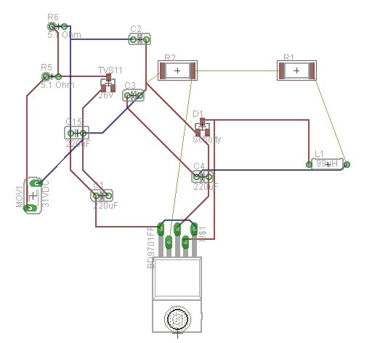

Figure 5.2.1.1: Placement of power components

The engineers from Motor Protection Electronics also informed the design team on the importance of having the components placed properly to eliminate electrical noise, which can interfere with the device performance. The design team suggested that we have two layers for traces to allow easy accessibility to the microcontroller. Also, the likelihood for an error taking place will diminish significantly during the construction process. It should also be noted that using smaller traces will prove beneficial. Another layer was used for the ground plane. The advantage of having a layer that is strictly for grounding eradicates the influence of power loss, Electromagnetic Interference, and overvoltage. The housing for the device will have a chassis ground attached to it. The ground plane will be attached to the chassis ground. This method plays a key role in removing Electromagnetic Interference. The last layer is reserve for power. Figure 5 gives a brief description is given on the power.PCB power.
5.2.2 PCB Specifications
The design team put together a list of specifications for the printed circuit board. The Eagle software was used to help with deciding the dimensions of the PCB. The specifications along with the schematics were sent to the some PCB vendors. Here on, the vendor will inform the design team if any modification needs to be done.
- 4 Layers
- Board Length: 3in
- Board Width: 4in
- Board thickness: .06in
- Copper thickness outer layer: .0014in
- Minimum Trace width: .01in
- Minimum hole size: .032in
- Casing Support
- Black solder mask
MPE has a standard order for their four-layer designs which is shown in the following figure. Shielding the ground and power planes helps avoid initiating a system reset from an EMI event, and placing the trace planes on the outside ensures that those traces are available for PCB surgery.
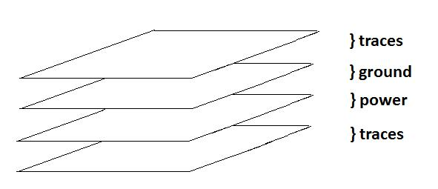
Figure 5.2.3.1: PCB layer order

5.2.3 PCB Vendor
The design team had an idea on what qualities are expected of the correct vendor chosen to build the printed circuit board. The specifications created were sent out to numerous PCB vendors around the country. One of the most crucial decision making process of this project is choosing the ideal vendor. Cost played an important role in choosing the PCB vendor that can fulfill the team’s desires. The design team had maximum amount of money reserved for the printed circuit board. A vendor was needed that can build and test the PCB in a reasonable time frame. Also a vendor was required that can review the specifications and schematics created by the design team before any arrangements could be made. The design team needs the PCB to be shipped out swiftly due to fact that the coding process needs to be started. This is the first time any member of the design team have ever designed a circuit board. Therefore, researches were carried out on eight different vendors. Recommendations from other previous senior design groups also helped with eliminating vendors that is not suitable for our requirements. Two vendors were chosen to give an illustration on what uniqueness strikes the team the most during the research process.

4PCB
4PCB is an excellent PCB manufacture that fit all of the design team’s requirements. 4PCB.com has one of the simplest quoting systems for first time users. They allow their customers to submit their schematics and have it reviewed in one day. After the reviewing process is done, they will inform customers on what changes should be made for no charge. In addition, the total cost to construct the PCB along with shipping is in the range of the group’s budget. For these reasons, the 4PCB was chosen to be the manufacture for the project’s PCB.

Express PCB
Express PCB proposes spectacular specials for their consumers. This manufacture has the most reasonable prices compared to the other vendors that were researched. Other senior design group stressed how flexible Express PCB can be if the PCB is needed to be shipped rapidly. However, Express PCB only flaw is that they do not specify on how they review schematics and if that service is free for first-time customers.
Best Global Source
Best Global Source is located in Apopka, which is adjacent to Orlando. The cost for shipping will be eliminated due to the fact that the PCB can be picked up by a member of the design team member. Similarly to other PCB vendors, Best Global Source reviews PCB and schematics free of cost. After submitting a quote to Best Global Source, their cost for constructing the PCB exceeded project’s budget.

Micro Engineering Inc.
Micro Engineering is another beneficial PCB vendor simply because of its location is adjacent to Orlando. Micro Engineering offers a rational charge to their customers that needs their circuit to be troubleshot or modified before the circuit board is printed. Surprisingly, Micro Engineering presented the cheapest price to manufacture the printed circuit board.

6 Testing
6.1 Hardware Testing
Test Number: | 1
Test Name: | Surge Protection Circuit
Test Time: | Bread boarding stage
Test Reason: | The surge protection circuit approves the power supply coming into the circuit board. It is mandatory to verify that unwanted voltages will be removed.
Test Procedure: | 1. A 24V DC power supply will be supplied to the circuit.  2. Periodically, the input voltage will be increased until it has reached the maximum which is 40V.  3. Place a multimeter across each surge protection components and at the circuit output. Record the results for each time the voltage is increased.  4. Place an ammeter at the surge protection circuit. Record the results for each time the voltage is increased.
Pass Requirements: | The metal oxide varistor and transient voltage surge suppressor reacts to overvoltage swiftly. The multimeter connected to the TVS should reveal an increase current and decrease in voltage produced by the TVS whenever the input voltage exceeds the TVS threshold voltage. The ammeter should never display a value that exceeds 67mA. This is the maximum input current the circuit can resist. Most importantly, the multimeter that is connected to the output of circuit should display a voltage value of 24V.
Test Number: | 2
Test Name: | DC-to- DC Converter
Test Time: | Bread boarding stage
Test Reason: | To prove that the circuit breaks down the 24V DC power supply to 3.3V and to make sure that the surge protection circuit does not negatively affect its performance.
Test Procedure: | 1. Connect the input of the DC-to- DC Converter circuit to the output of the surge protection circuit.  2. Repeat the test procedures carried out for the surge protection circuit.  3. A multimeter will be connected at the output of the switching regulator and at the output of the  DC-to- DC Converter circuit.  4. Record measurements taken from the multimeter connected to the DC-to- DC Converter circuit.  5. Repeat Step 4 while DC-to- DC Converter is supplying the circuit board.  6. Change the resistors from the voltage divider portion of the circuit to produce 2.5V.
Pass Requirements: | The DC-to-DC converter circuit and the surge protection circuit should be able to interact and supply power to the circuit load. The converter should constantly supply 3.3V to allow the devices on the circuit board to ensure that it the needs power supply to functions properly. The adjustable resistors should produce the desired value after changing the initial values.

Test Number: | 3
Test Name: | Clock Backup Battery
Test Time: | Bread boarding stage
Test Reason: | The clock must have the accurate date time after a power outage occurs. The test purposely done to confirm that the backup battery supply is swiftly activated whenever it is called upon.
Test Procedure: | 1. Apply power to the circuit.  2. Allow the microcontroller to function.  3. Check the clocks current status and record its values. Check to see if the clock is functioning properly.  4. Cut the power supply for the circuit board.  5. Reduce the clock power to 2.5V.
Pass Requirements: | The clock back circuit is activated after the main power supply is removed. Also the backup battery should be activated if low voltage is detected. The backup battery must keep the clock functioning for a minimum time of two hours if the main power supply is not available.

Test Number: | 4
Test Name: | Cyclone Pro Programmer
Test Time: | Bread boarding stage
Test Reason: | The microcontroller must be updated occasionally along with the method to permit the effective use of the programmer. The test must be done to verify that no delay will occur due to the two devices not cooperating.
Test Procedure: | 1. Apply power to the circuit by connecting the circuit board housing to the DIN rail mount.  2. Connect the Cyclone Pro Programmer cables to the Reset and Background port of the microcontroller.  4. Add a 3.3V power supply to the Cyclone Pro Programmer power supply port.  3. Update the microcontroller with new code.
Pass Requirements: | Any USB Multilink Programmer should be able to connect to the circuit board to make any necessary changes to the microcontroller

Test Number: | 5
Test Name: | Microcontroller Low Voltage Reset
Test Time: | Bread boarding stage
Test Reason: | To confirm that the microcontroller Low Voltage Reset is activated whenever low voltage is detected. Also to verify that if a situation occurs that results in the microcontroller being placed in the reset state, the LVR will successfully force the microcontroller to return to its normal state
Test Procedure: | 1. Connect circuit board housing to the DIN rail mount to all the circuit board to receive the 24V DC power supply.  2. Check to see if the microcontroller is receiving data from the Modbus port.  3. Reduce the input power to circuit to 20 V.  4. Apply the correct amount power supply to the circuit.
Pass Requirements: | The microcontroller is constantly receiving the required power while in the normal state. The Low Voltage Reset should not allow the microcontroller to function if low voltage is identified but it should force the microcontroller to the reset its state and place it back in the regular state as soon as the voltage is equalized.

Test Number: | 6
Test Name: | Ethernet Controller Power-Fail Reset
Test Time: | Bread boarding stage
Test Reason: | To check that the Ethernet controller will be placed in the reset state if its power supply fails or low voltage occurs. Also to prove that the Ethernet controller will return to its normal state after the power conditions are standardized.
Test Procedure: | 1.Connect the circuit board housing to the DIN rail mount, to obtain the power supply.  2. Reduce the power supply to the Ethernet controller to 2.5V.  3. Transition the power supply to its normal distribution value.
Pass Requirements: | The Ethernet controller functions properly by receiving the Modbus data and outputting the DNP3 data.

Test Number: | 7
Test Name: | Ethernet Connectors
Test Time: | Bread boarding stage
Test Reason: | To make sure that Modus and DNP3 data can easily enter and exit the circuit board. Any data can be inputted into the microcontroller by using the correct device with its cable jack.
Test Procedure: | 1. Make sure the circuit board is powered-up.  2. Check to see if cables are connected to the Ethernet Connectors.  3. Ensure that the connectors are secured correctly to the Ethernet controller.
Pass Requirements: | The Modbus data enters the microcontroller and converts to DNP3 data that will be leaving the circuit board.

Test Number: | 8
Test Name: | Microcontroller Voltage Regulator Power-On Reset
Test Time: | Bread boarding stage
Test Reason: | The microcontroller voltage regulator needs the accurate amount of power supplied to it so distribute power to the microcontroller internal components. Therefore, if the power supplied to the voltage regulator is not sufficient during the power-up mode, it will be forced to reset on every occasion the input power supply for microcontroller voltage regulator is at its required value
Test Procedure: | 1. Apply power to the circuit board.  2. Make sure the microcontroller voltage regulator receives its required power supply.  3. Reduce the power supplied to the voltage regulator.
Pass Requirements: | The voltage regulator goes into reset mode whenever the input power is not adequate during the power-up process.

Test Number: | 9
Test Name: | Microcontroller Voltage Regulator Low-Voltage Reset
Test Time: | Bread boarding stage
Test Reason: | The microcontroller LVR test should be sufficient but that test does not cover the voltage regulator activities. A test needs to be done to prove that Low- Voltage Reset is monitoring the primary voltage V_{DD}.
Test Procedure: | 1. Check to see if the circuit board is powered-up.  2. Make sure the microcontroller voltage regulator receives its required power supply.  3. Reduce the power supplied to the voltage regulator.  4. Proceed to provide the normal power supply to the voltage regulator.
Pass Requirements: | Low Voltage Reset forces the microcontroller into reset mode for low voltage detection. Also, the LVR converts the microcontroller to its normal mode after no more low voltage is identified. The change of states does not affect the microcontroller sense of duty.

Test Number: | 10
Test Name: | Microcontroller Voltage Regulator Low-Voltage Detect
Test Time: | Bread boarding stage
Test Reason: | The Low Voltage Detect is similar to Low Voltage Reset but a test is important for LVD to validate that the status flags are correctly updated when low voltage is detected
Test Procedure: | 1. Make sure the circuit board is receiving the necessary power supply.  2. Check to see if power supply is available for the V_{DDA} pin of the microcontroller.  3. Reduce the power supplied to the V_{DDA} pin of the microcontroller.
Pass Requirements: | The LVI sets the status bit LVDS with the correct value whenever unbalanced voltage situations occur.

Test Number: | 11
Test Name: | Structural
Test Time: | First stage
Test Reason: | As stated before, the design will be used for real-life applications. Therefore, it is critical to have the custom-made housing for the circuit board thoroughly tested for different weather conditions, proper grounding and, feed through power.
Test Procedure: | 1. Attach the circuit board to the DIN rail.  2. Use a multimeter to verify that the power is being feed through the DIN rail clamp to supply the circuit board.  3. Check to see if the circuit board housing is properly grounded.  4. Fluctuate the input power supply and use a multimeter to verify that the circuit board is experiencing similar changes as the input power supply.  5. Change the room temperature to 50˚F. Allow the room temperature to remain constant for 30 minutes. Examine the circuit board for any abnormal activity. Also use a multimeter to check the voltage across each device on the circuit board and compare those results to the normal specifications for each device.  6. Change the room temperature to 80˚F. Repeat the procedure steps carried out for the previous room temperature setting.  7. Disconnect the circuit board case from the DIN rail. Attach the circuit board to the DIN rail and repeat steps 2-3.
Pass Requirements: | The DIN rail connector connects to the DIN rail mount to supply the 24 V DC supply to the circuit board.

Test Number: | 12
Test Name: | Microcontroller Pins Power
Test Time: | Bread boarding stage
Test Reason: | To verify that the microcontroller pins are receiving the required amount voltage supply. Also, the test is needed to make sure that each pin is being occupied.
Test Procedure: | 1. Make sure the circuit board is receiving the necessary power supply.  2. Check to see if power supply is available for each pin of the microcontroller.  3. Use the microcontroller manual to check that each pin is properly connected.  4. Use a multimeter to verify that each voltage dependent pin receives a 3.3 V.  5. Use an ammeter to confirm that the correct amount is going to each pin.  6. Periodically, increase the input power supply in increments of one until the 30V max is reached. Use a multimeter to record the voltage values.
Pass Requirements: | Each is occupied to allow the microcontroller to fulfill its duties

6.2 Software Testing

Test Number: | 1
Test Name: | Initialization
Test Time: | First Debugging stage
Test Reason: | This test is to see if all controllers and hardware is properly initialized on start up.
Test Procedure: | - First the device is to be plugged into the power source.  - The device will then power up each sub controller.  - The power up of the MCU will then cause each sub device’s reset mode to trigger.  - When the Display is initialized properly the display will cycle codes from 90-96.  - When the MCU is initialized a code of 99 will display.  - When the Modbus Ethernet controller initializes a code of 98 will display.  - When the DNP3 Ethernet controller initializes a code of 97 will display.  - Unplug the power source.
Requirements for Pass: | Each of the codes from 90-99 must display.  Startup must not take more than 30 seconds.
Test Number: | 2
Test Name: | Date and Time setting
Test Time: | First Debugging stage
Test Reason: | This test is to verify that the date and time can be set by the display and then to verify that it is saved in the memory.
Test Procedure: | - Plug the device in  - Wait for device to power up and cycle through the initialization phase.  - Once powered up scroll through the display menu to dt listing and select that code.  - The first value displayed will be the month.  - Set the month to the current month plus 1.  - Save the value and scroll to the next value.  - This will be the day.  - Select the current day minus 2.  - Save the value and scroll to the next value.  - This will be the year.  - Select the current year minus 5.  - Select the next value.  - This will be the hour.  - Select the current hour.  - Scroll to the next value. This is the minute.  - Select the current minute.  - Scroll to the last value and set the seconds.  - Select again, and then back out of the menu.  - Power off the Device.  - Power on the Device and scroll to the dt listing.  - Verify each value you entered was stored.
Requirements for Pass: | The month day and year must be stored correctly.  The time must have incremented in the correct amount of time that it took to power down and repower the device.
Test Number: | 3
Test Name: | Verify timer reset setting
Test Time: | First Debugging stage
Test Reason: | This test is to verify setting of the reset cycle timer
Test Procedure: | - Plug the device in  - Wait for device to power up and cycle through the initialization phase.  - Once powered up scroll through the display menu to rt listing and select that code.  - On the menu set the reset timer to 3.  - Power off the device  - Power on the device  - Cycle through the menu to rt and verify the value displayed matches the value entered.
Requirements for Pass: | Displayed value must match the value entered

Test Number: | 4
Test Name: | Verify Security Decode
Test Time: | First Debugging stage
Test Reason: | This test is to see if the security object is correctly identified and then validated.
Test Procedure: | - Plug the device in  - Wait for device to power up and cycle through the initialization phase.  - Send a polling request into the device.  - Check the output of the DNP3 encodes function.
Requirements for Pass: | Security code must correctly validate if code matches the device.  It must ignore the poll if it does not match the device.

Test Number: | 5
Test Name: | Verify Security Encode
Test Time: | First Debugging stage
Test Reason: | This test is to see if the function adds the correct security object to the outgoing data stream.
Test Procedure: | - Plug the device in  - Wait for device to power up and cycle through the initialization phase.  - Send a data stream into the device.  - Check the output of the DNP3 decodes function.
Requirements for Pass: | Security code must correctly validate if code matches the device.  It must recall the decode function if it does not validate.

Test Number: | 6
Test Name: | Verify Event Recording
Test Time: | First Debugging stage
Test Reason: | This test is to see if the event recording function correctly records any event change
Test Procedure: | - Plug the device in  - Wait for device to power up and cycle through the initialization phase.  - Force pump one of the Modbus registers to change value.  - Set Output to display the error before calling the event recording function.  - Set Output to display the error after the date and time stamp is added to the error stream.  - Set output to display after event recording function ends.
Requirements for Pass: | Output must display correct values on each print out.

Test Number: | 7
Test Name: | Verify DNP3 to Modbus conversion
Test Time: | First Debugging stage
Test Reason: | This test is to see if the DNP3 data stream correctly converts to Modbus protocol
Test Procedure: | - Plug the device in  - Wait for device to power up and cycle through the initialization phase.  - Set DNP3 data stream to match a polling request.  - Output each register that is used to change DNP3 to Modbus.  - Output the entire Modbus data stream at the end of the conversion to verify correct conversion.
Requirements for Pass: | Outputted data stream must be in correct Modbus protocol.

Test Number: | 8
Test Name: | Verify Modbus to DNP3 conversion
Test Time: | First Debugging stage
Test Reason: | This test is to see if the Modbus data stream correctly converts to DNP3 protocol.
Test Procedure: | - Plug the device in  - Wait for device to power up and cycle through the initialization phase.  - Set the Modbus data stream to match an all clear flag.  - Output each register that is used to change Modbus to DNP3.  - Output the entire DNP3 data stream before it goes into the DNP3 encode function.  - Verify that the conversion was completed correctly.
Requirements for Pass: | Outputted data stream must be in correct DNP3 protocol.

Test Number: | 9
Test Name: | Check Error Storage Size
Test Time: | First Debugging stage
Test Reason: | This test is to verify that only a maximum of 20,000 events are stored at any time. The oldest events stored should be removed once the 20,000 event threshold is passed.
Test Procedure: | - Plug the device in  - Wait for device to power up and cycle through the initialization phase.  - Create a loop of 20,100 Error events  - Run loop and output each error as its stored  - Compare the 20,000 stored events with the initial list that was run.
Requirements for Pass: | Stored list must match the last 20,000 events run, and have discarded the first 100.

Test Number: | 10
Test Name: | Error list Clear
Test Time: | First Debugging stage
Test Reason: | This test is to verify the error list clear function. The function is in place in the event the gateway owner wants to do a full clear of the log.
Test Procedure: | - Plug the device in  - Wait for device to power up and cycle through the initialization phase.  - If error log is empty, create a loop to enter 5,000 errors. Else skip to step 6.  - Run the loop to store the 5,000 errors  - Display the stored list to verify errors recorded correctly.  - Run the error list clear function.  - Display the stored list.
Requirements for Pass: | Entire stored error list must be removed from memory.

Test Number: | 11
Test Name: | Validate Display is fully functioning
Test Time: | Before Final Release
Test Reason: | This test is to see if all settings are available to be accessed in the display.
Test Procedure: | - Plug the device in  - Wait for device to power up and cycle through the initialization phase.  - Cycle through the display.  - At each parameter select the parameter.  - Verify a value is stored for the parameter
Requirements for Pass: | The Parameters stored must match the start up profile listed for the device

Test Number: | 12
Test Name: | Test Full Data Stream
Test Time: | Final Release
Test Reason: | This test will send a full polling request to the device to verify all parts are functioning and communicating properly
Test Procedure: | - Plug the device in  - Wait for device to power up and cycle through the initialization phase.  - Send the Polling request for two devices into the gateway.  - The first will not be marked for the gateway.  - The second will be marked for the gateway.  - Check the output at the return of each function in the data path.  - Verify data stream is correct on exiting the device
Requirements for Pass: | The returned DNP3 data stream must be correct showing the correct errors.  This is the final test to pass before the device is marked ready to deliver.

7 Administrative
7.1 Financials

The Modbus to DNP3 Gateway project is funded by entirely by the project sponsor, Motor Protection Electronics. The design team, made up of full-time students who are not all employed, is grateful for their support. It hopes to exceed the sponsor’s expectations in the execution of the project. As of today, the total project budget total is $657.11.The most expensive part used will be the cyclone pro programmer, which costs approximately $500. This part alone consumes 75% of the project budget. Motor Protection Electronics has a Cyclone Pro unit on hand, so the need for this part could potentially add zero to the project budget and the total cost would come in at under $160. The table below summarizes the cost of each part.

Component | Price | Quantity | Total
Clock | $2.34 | 4 | $9.36
Clock-Back Battery | $4.28 | 1 | $4.28
Microcontroller | $22.85 | 1 | $22.85
Switching Regulator | $3.75 | 1 | $3.75
Schottky Diode | $0.55 | 1 | $0.55
TVS Diode | $0.73 | 1 | $0.73
Inductor | $3.56 | 1 | $3.56
LCD Driver | $1.75 | 1 | $1.75
3-Digit 7-Segment Display | $2.91 | 1 | $2.91
Ethernet Controller | $5.83 | 2 | $11.66
Ethernet Connector | $4.73 | 2 | $9.46
Super-Red LED | $1.08 | 2 | $2.16
Cyclone Pro Programmer | $498.80 | 1 | $498.80
Metal Oxide Varistor | $0.56 | 1 | $0.56
Din Rail Connector | $1.54 | 1 | $1.54
Case | Donated | 1 | Donated
PCB | $80.00 | 1 | $80.00
Pin Connector | $0.15 | 3 | $0.45
Resistor | $0.02 | 17 | $0.34
Capacitor | $0.12 | 20 | $2.40
Total |  |  | $657.11
Table 7.1: Project Budget

Tentatively, the team hopes to also order an evaluation board for the system microcontroller. This part, the EVB9S12XDP512E from Freescale Semiconductor, would cost another $395. Because of the cost, it will only be ordered if it is deemed vital. Further discussion with the project sponsor will focus on whether this part may be procured and whether it will be necessary.

7.2 Milestones

The project documentation concludes with a list of past and present milestones. Milestones will cover two semesters and as such will be split into two parts. All milestones in the Spring Semester are estimated dates.

Fall Semester

8/21/12: Group was formed and possible project topics were discussed in brief after class.

8/23/12: Motor Protection Electronics Inc. presentation in class, group shows interest, serious talks and plans to go after sponsorship.

8/28/12: Joshua Daly makes initial contact with John Evans of MP Electronics Inc. inquiring for more information.

9/4/12: Group Identification assignment assigned. Brief talks about which topics the group want to go with for our project. Sponsored by Motor Protection Electronics Inc is by far the top choice. Group receives response from John Evans giving us some more specifics on the project.

9/4/12: First official group meeting at UCF, finalize that the first choice for a project is the DNP3 Controller sponsored by Motor Protection Electronics Inc. Back-ups include a sponsored medical sensor project and a non-sponsored project involving some simple AI.

9/9/12: Official meeting held at the UCF library to work on first assignment. Initial project proposal is written, as well as a very basic timeline created for the group to schedule around.

9/10/12: Dropbox created for the group to start working on documentation with each other.

9/11/12: Joshua Daly has initial face to face meeting with John Evans at Motor Protection Electronics Inc. in Apopka. John seemed happy with the meeting, orders the group “Practical Modern SCADA Protocols: DNP3, 60870.5, and Related Systems" and goes over rough outline for the project.

9/13/12: Initial meeting of group and Dr. Richie. The project is discussed; most of the design seems to be up to par. Talks on possible extra features to be added to make the device a little more complex explored. Confirmation was made that the group was selected for sponsorship.

9/16/12: Official meeting held at the UCF library to go over what was discussed with John Evans at meeting. Research starts on Modbus and DNP3 for computer engineers, circuit design started for electrical engineers.
9/23/12: First virtual meeting for group over skype, general progress checks are made as well as the first group meeting with John Evans is talked about and scheduled to happen soon.

10/11/12: Table of Contents assignment assigned, group sets meeting for weekend to complete assignment. Microprocessor is selected for project.

10/12/12: Daniel Doherty starts talks with sales rep at Freescale to see if there is any Codewarrior suite that would fit the group’s needs is led to check of the trial version of the basic suite.

10/14/12: Official meeting held at the UCF library to design the Table of Contents for the project. Design of this starts the beginning of the final documentation for group’s senior design project.

10/18/12: First full group meeting with sponsors at Motor Protection Electronics Inc. in Apopka. John Evans is out of town, meeting is with their Electrical Engineer Chris Parker. It is decided that the microprocessor would not work for what the clients wanted; group needs to find a new option.

10/24/12: First software discussion meeting, the high level information flow of the system is designed.

11/1/12: First full group meeting with John Evans a Motor Protection Electronics Inc. in Apopka. Some demonstrations of current system were shown to the group. Set up a date to show the complete circuit drawn up in AutoCad at the next meeting with John in two weeks.

11/3/12: Official meeting held at the UCF library to work on design of circuit, as well as status check to make sure most of the research for the project is done, as well as group starting on the final documentation.

11/8/12: Mac Lightbourn and Joseph Wilkinson finalize circuit layout for the DNP3 Controller.

11/12/12: The circuit design is drawn up in AutoCad and finalized in preparation for next meeting at MP Electronics.

11/15/12: Circuit design presented to John Evans at MP Electronics.

11/18/12: Official meeting held at the UCF library to discuss the rest of the documentation that needs to get done over the thanksgiving break, making sure everyone is on pace.

11/29/12: Meeting at Motor Protection Electronics Inc. in Apopka to touch base with sponsors before the Christmas break. Senior Design 1 Final documentation Finished.

12/6/12: Senior Design 1 Final documentation submitted.

Spring Semester

1/11/13: First lab of Senior Design 2. Group starts purchasing components for project.

1/13/13: Official meeting held at the UCF library to discuss the schedule for the coding and assign functions to be coded.

1/17/13: First meeting back after Christmas at Motor Protection Electronics Inc. to review current status of project with John Evans.

1/31/13: Meeting at Motor Protection Electronics Inc. to do final review on board design.

2/4/13: Designs finalized and board sent for printing.

2/14/13: Meeting at Motor Protection Electronics Inc. to update sponsors on project and get advice for proceeding from this point.

2/21/13: Meeting at Motor Protection Electronics Inc. to update sponsors on project.

2/24/13: Coding Finished.

3/1/13: Prototype finished.

3/7/13: Meeting at Motor Protection Electronics Inc. to update sponsors on project and revisions if necessary.

3/20/13: Initial testing finished.

3/21/13: Meeting at Motor Protection Electronics Inc. to update sponsors on project and revisions if necessary.

4/1/13: Final testing finished.

4/4/13: Senior design project finished and turned over to sponsor.

4/9/13: Begin working on final presentation.

4/14/13: Official meeting held at the UCF library to finalize the presentation and make any necessary adjustments.

TBD: Final presentation.

TBD: Final Documentation Due

Appendices

Appendix A: Permissions

Title Art:
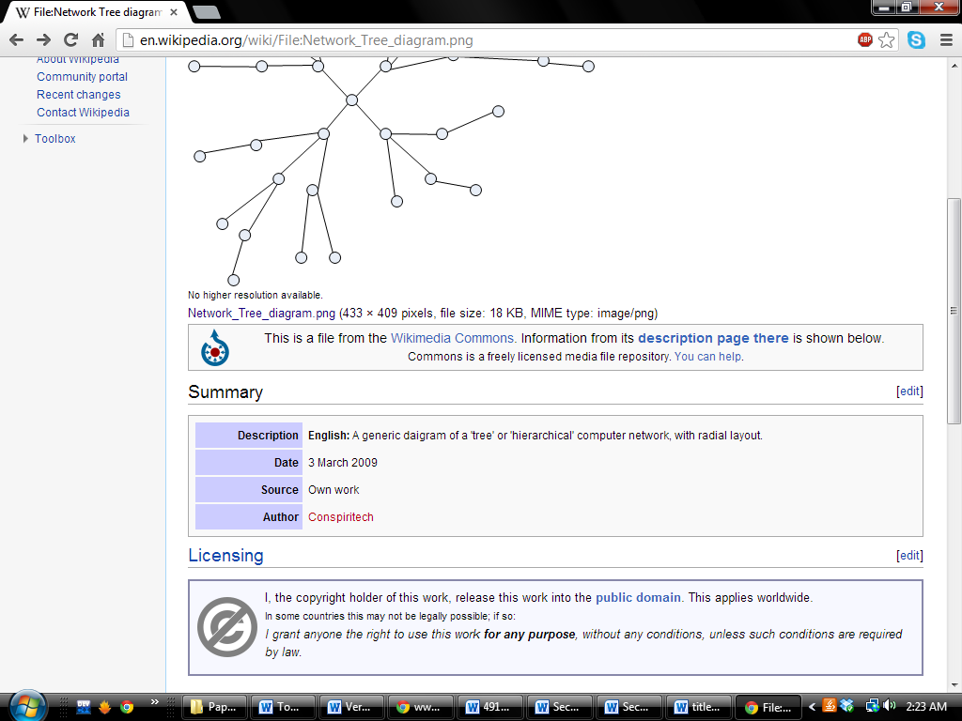

Freescale (permission pending):
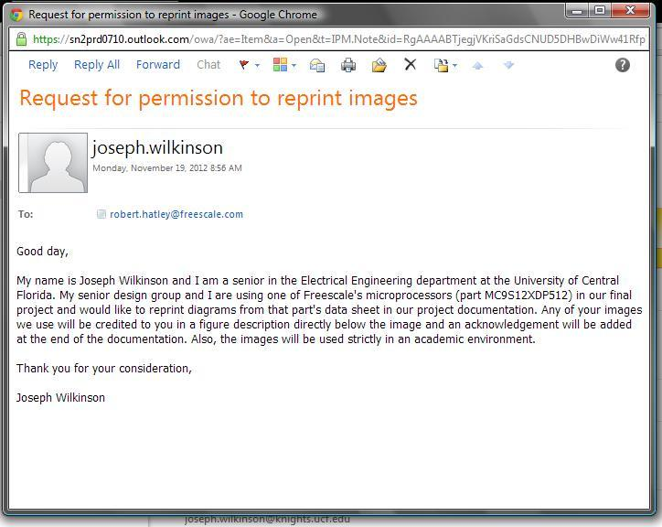

Silicon Labs (permission pending):
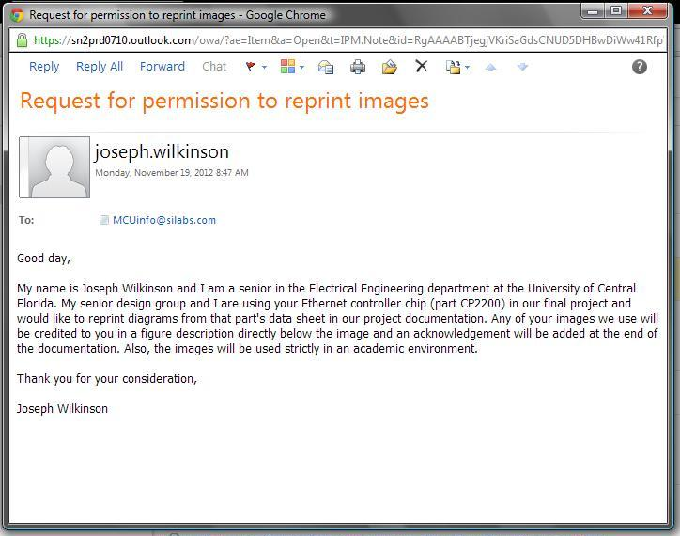

V-model

Spiral model


Agile model
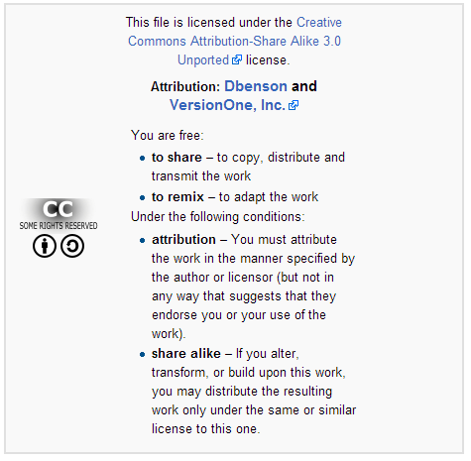
Iterative model

Waterfall model


DCB


Pro-Soft


Kalkitech


RuggedServer™ RS910 2-Port

From: Josh Daly
Sent: Tuesday, November 27, 2012 1:53 PM
To: 'RuggedInfo@ruggedcom.com'
Subject: Copyright Permission

I am an engineering student at the University of Central Florida and I’m doing a senior design project
paper on Modbus to dnp3 devices. I would like permission to use an image of your:

RuggedServer™ RS910 2-Port

Thank you,

Joshua Daly
Appendix B: Modbus Registers
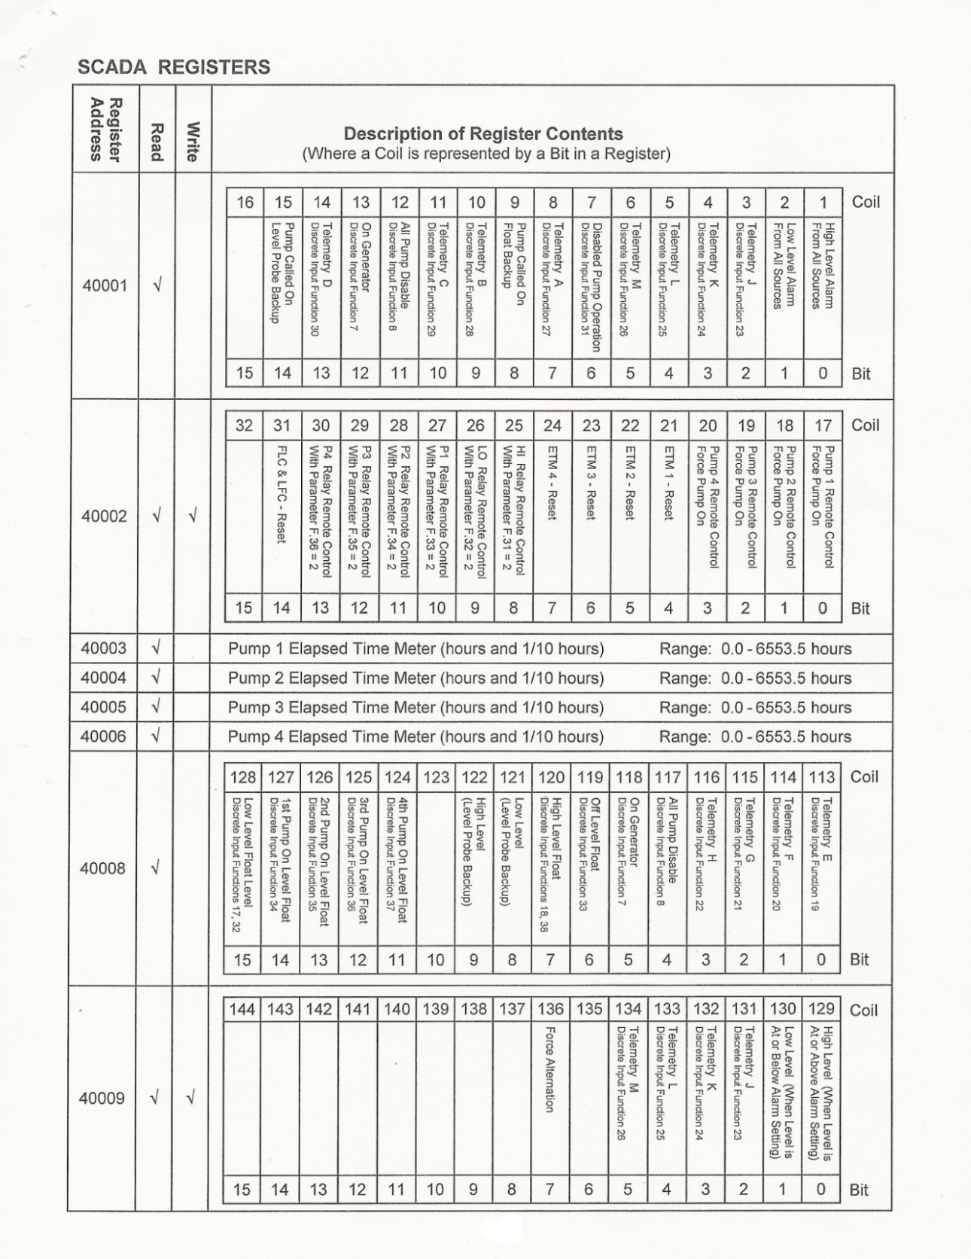
Figure App.B.1: Modbus Register list 1
Reprinted with permission from MPE

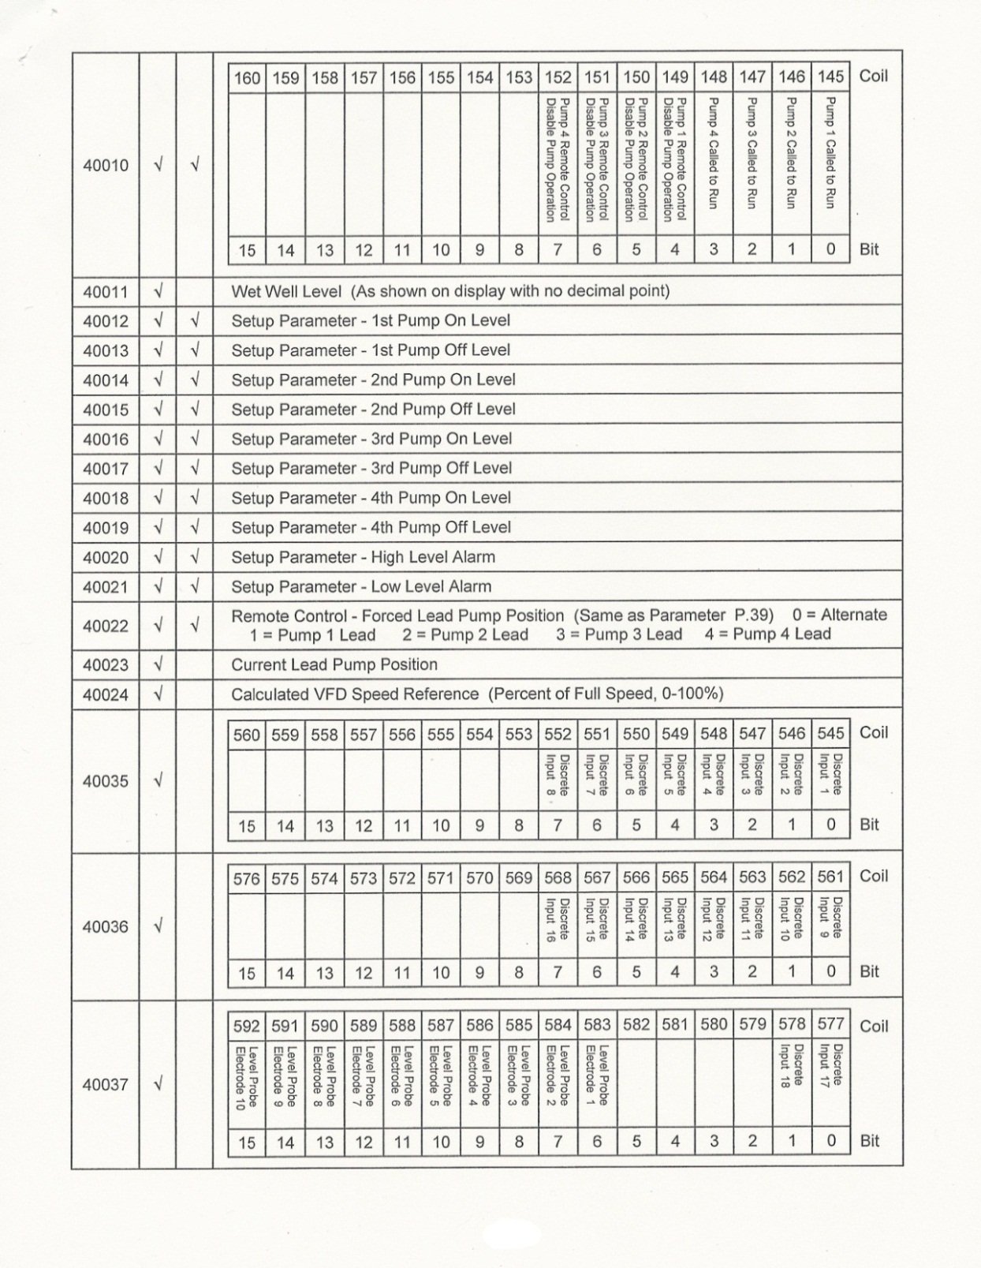
Figure App.B.2: Modbus Register list 2
Reprinted with permission from MPE

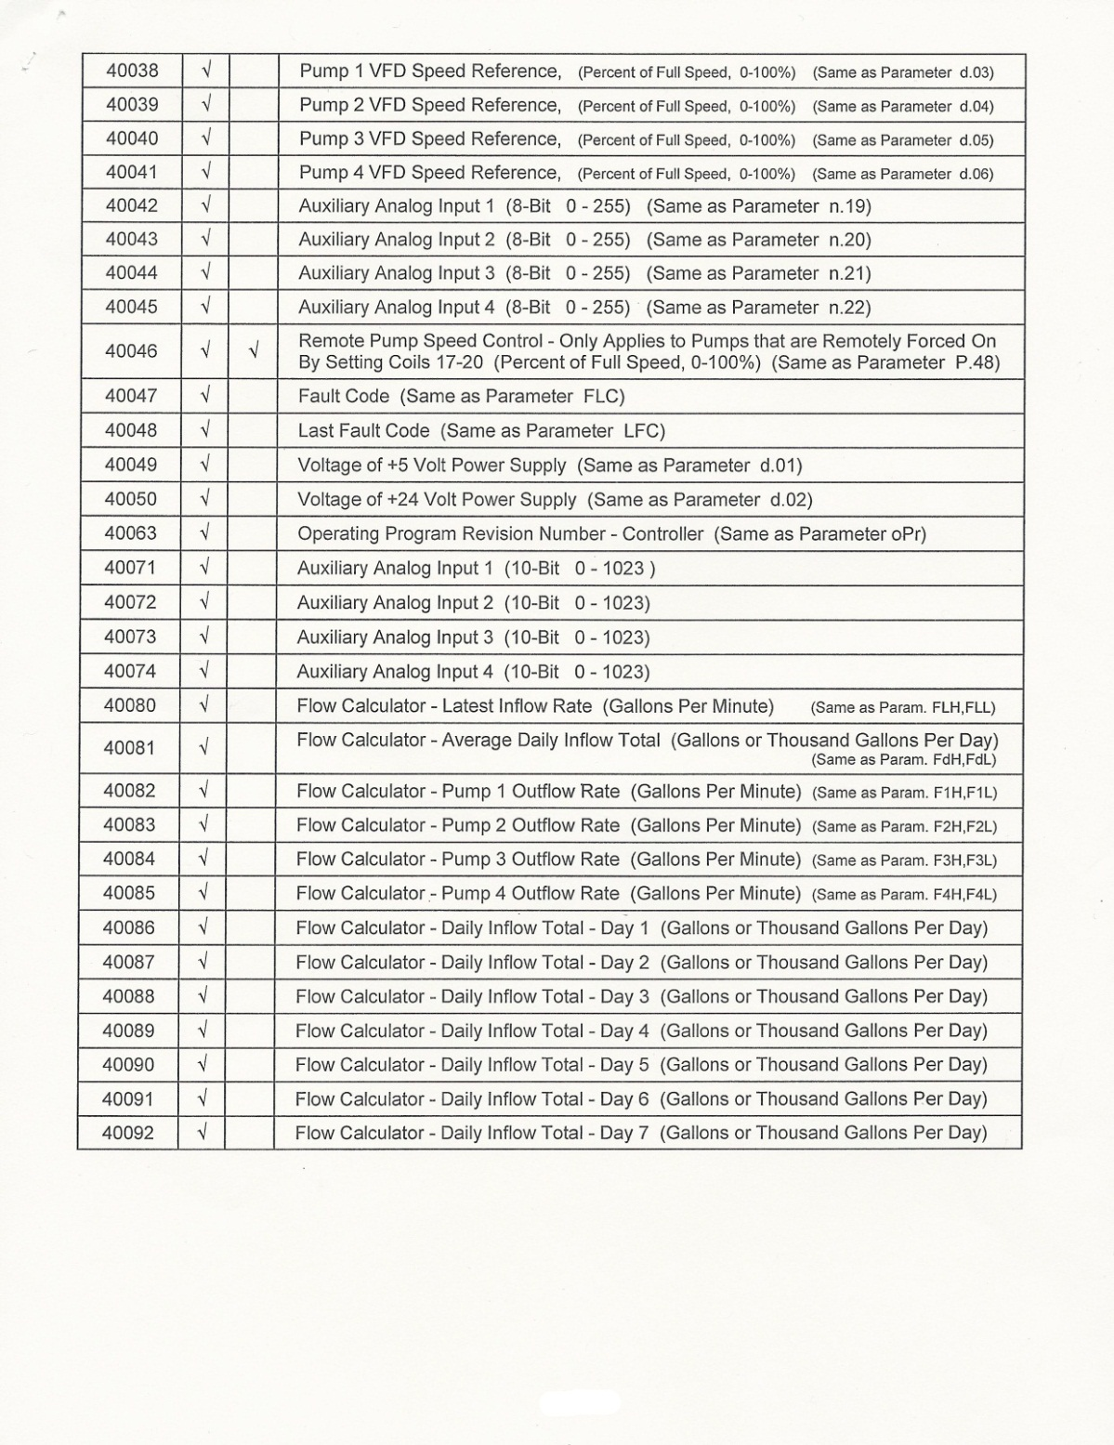
Figure App.B.3: Modbus Register list 3
Reprinted with permission from MPE

